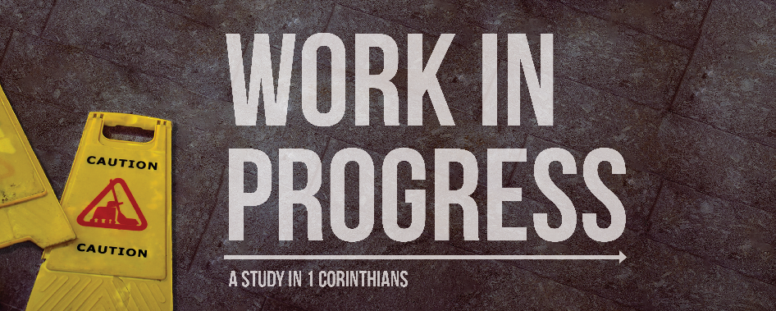
What Gives You the Right?
1 Corinthians 9:1-23
Paul is dealing with people who think they have the right to eat food that has been sacrificed to idols, and even to go so far as to eat it in an idol’s temple. Although Paul is going to warn them explicitly about the danger of such activity, he first wants them to see that their actions have been self-focused and wrong.

Paul establishes his rights (1 Corinthians 9:1-14)
What authority does Paul have to demand rights according to the first few verses (9:1-2)? ___________________________
___________________________________________________
___________________________________________________
___________________________________________________
___________________________________________________

What rights does Paul give up (9:3-6)?___________________
___________________________________________________
___________________________________________________
___________________________________________________
___________________________________________________

What right does Paul spend the most time discussing, and what type of arguments does he put forward for why he should he have that right? ______________________________________
___________________________________________________
___________________________________________________
___________________________________________________
___________________________________________________
___________________________________________________
___________________________________________________

Paul sacrifices his rights for the gospel (1 Corinthians 9:15-23)
What does Paul mean by “glorying” or “boasting”? What is his only grounds for boasting? Why is this? (15-18) ___________
___________________________________________________
___________________________________________________
___________________________________________________
___________________________________________________
___________________________________________________
___________________________________________________

What general statement do we find that sums up Paul’s thinking in these verses? What does he mean by this? _______
___________________________________________________
___________________________________________________
___________________________________________________
___________________________________________________

What does Paul mean when he talks about the law and specifically what does he mean by “not being under the law” (19-23)? ____________________________________________
___________________________________________________
___________________________________________________
___________________________________________________
___________________________________________________
___________________________________________________

Application – How can we live this way?
Summarize Paul’s argument in a single sentence: __________
___________________________________________________
___________________________________________________
___________________________________________________
What are some rights that believers can give up today for the sake of the gospel? ___________________________________
___________________________________________________
___________________________________________________
___________________________________________________
Why do we naturally resist giving up our rights? ___________
___________________________________________________
___________________________________________________
___________________________________________________
___________________________________________________
___________________________________________________
What is the solution for overcoming this selfishness?
___________________________________________________
___________________________________________________
___________________________________________________
___________________________________________________
___________________________________________________

