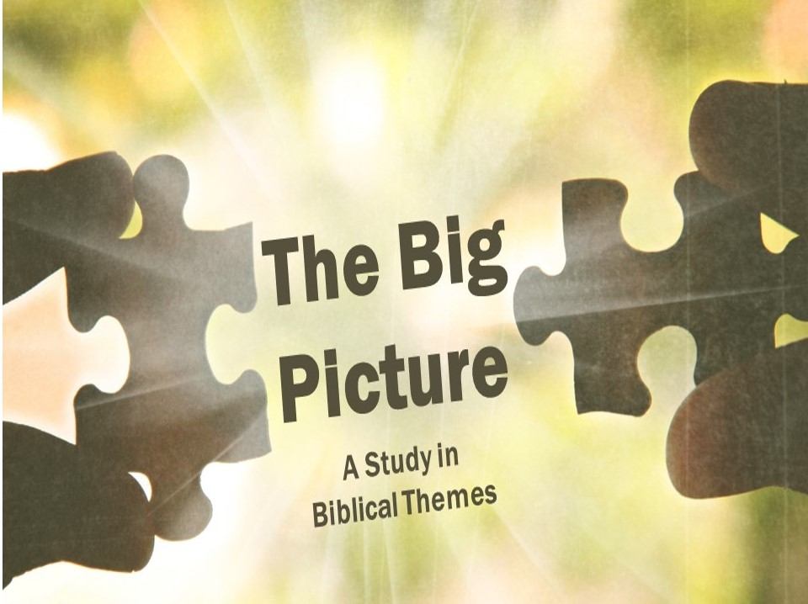

Part 2: The Temple in the New Testament
Begin by reviewing last week’s lesson. Ask your table what they remember, and of course make sure you’re able to give a summary at the end before launching into part 2.
Our last lesson ended on a depressing note – God’s presence departed from the temple. Although the Temple was rebuilt under the direction of Zerubbabel and Josiah, we don’t read of God’s special presence coming to it like we did with the Tabernacle or the first temple. Ezekiel had prophesied that God’s glory would one day return to the new temple (Ezekiel 44:4; 48:35), but by the end of the Old Testament, that hadn’t happened.
- Jesus
God had come to dwell with his people in the Temple, but because of their sin he left. For over 500 years they eagerly awaited the return of their God. While God still watched over and protected his people (see Daniel and Esther), his presence wasn’t with them in the same way. And so the nation waited for God to return to them in a physical, tangible way. That’s where Jesus comes in.

- A special name (Matthew 1:23)
Understanding this background is what makes Christmas so special. Christmas? Yes, Christmas. This theme we have been studying explains why the incarnation mattered so much. God coming to dwell with his people wasn’t a surprise; it was what they expected because it was what God had promised. How it worked out was a surprise, but all Jews were expecting God’s glory to return.

This explains why the angel made that famous pronouncement to Joseph: “‘and they shall call his name Immanuel’ (which means, God with us).” God had come, but he came in a way no one really expected: the glory of the creator God returned to Israel in the form of a little baby.

How does understanding the theme of the Temple help make the Christmas story come alive more? Why do we so often fail to see this theme?

- A special day (Matthew 17:1-2)
For the most part, Christ looked like any other human. Scripture actually tells us that he looked pretty plain (Isaiah 53:2). But there was an exception to this rule, at least once. Matthew, Mark, and Luke all tell us about the time that the glory of God in Jesus shone through so that everyone there (Peter, James, and John) were able to see Jesus for who he really was. The glory of God was with his people, even though they normally couldn’t see it. Significantly, both Peter (2 Peter 1:16-18) and John (John 1:14) looked back on this event as being very important for them in witnessing that Christ is who he said he is.
Why do you think the transfiguration matters in the ministry of Jesus? Why do Peter and John point back to it?

In the Old Testament, this brilliant glory and cloud were associated with the presence of God (Psalm 104:2; Exodus 24:16-17). Moses, after being in the presence of God, had his own face shine (Exodus 34:29-35). But now the brilliant glory of God’s presence that had once stood over the tabernacle and had come to dwell in the temple was now shining forth from the face of Christ. This brilliant glory was a sign of the divinity of Christ during his earthly ministry.

- A special promise (John 16:5-7)
Christ is telling his disciples that he will be leaving them, and they are understandably very sad. But he tells them that his leaving them is actually a good thing, because when he leaves he will send the Spirit!

Why is it better to have the Spirit than to have Christ physically present here on earth?

Why do we struggle to believe it is better to have the Spirit?

- Pentecost
So God came back as Jesus, and then left. But he promised when he left that he was sending Someone else who would be, not just with his followers, but now would actually be in them! (John 14:17) So the disciples did what Jesus told them to do: they waited. And then 40 days later, God showed up again in a big way.

- Fire from heaven.
Perhaps you’ve found this passage confusing. Why are there “divided tongues of fire?” How is that the picture of the Holy Spirit? Just as we saw that brilliant light is a sign of God’s presence in the Old Testament, fire is likewise often a picture of God, especially related to his glorious presence (Genesis 15:17-20; Exodus 3:2, 13:21; Ezekiel 1:27). The “tongues” is a description of what the fire looked like that also hinted at what was about to happen (2:5-13). That these tongues are divided probably refers to the fact that it was one Spirit who had been divided amongst the apostles.

The point of this passage, then, is that God had come back and was now resting on/in his people. Now he no longer just walks among them, so that he can only talk to one person at a time and be in one place at a time. Now he is with all his people all the time.

Look up and summarize the following passages that describe the difference having the Spirit makes (Romans 8:15-17, 26-27; 1 Corinthians 2:10-12; Galatians 5:22-23).

- Individual believers are the Temple now (1 Corinthians 6:18-20).
Paul is dealing with a church that has some believers who are pretty flippant in the way they are treating immorality. It seems that he quotes the argument they have been using “Food is for the belly and the belly is for food” (6:13). In other words, you have physical appetites, and you satiate them. You get hungry, you eat. You lust, you commit immorality. No big deal, right?

Paul responds with an emphatic “Absolutely wrong!” The body does matter for three reasons. 1) Bodies will be resurrected (the Corinthians weren’t clear on this point, see chapter 15), and so what you do with them now matters. 2) Your bodies are part of the body of Christ, so don’t join Christ to a prostitute. 3) Your body is the temple of the Holy Spirit. Don’t defile God’s temple.

How does thinking about our bodies as the dwelling of the Holy Spirit change the way we act?

Why do people not think about or care about this radical spiritual truth?

- Believers as a group are the Temple now (Ephesians 2:19-22).
The image here is that God is building himself a new temple, and we are the bricks! God dwells in each believer individually, but there is also a sense in which he dwells in all believers as a whole. It’s right to say, “I am the temple,” but it’s also right, and just as important, to say “We the church are the temple!”

How does thinking about all believers as part of the Temple change the way I think about my fellow believers?

Why is this emphasis so often missing in our churches?

- Millennium
As we are about to see in a minute, the new heavens and earth don’t have a temple. This has led to a problem with the Ezekiel passage we mentioned at the beginning. Namely, when will this temple be built? While Israel did rebuild a temple, the massive structure described in Ezekiel was never built. The answer to this dilemma lies in the millennium.

Even though it is never described as having a temple in Revelation 20, the millennium makes the most sense because it is a time of international attention on Israel. This is a detailed theme that would take us awhile to work through, and many would argue that the temple in Ezekiel is simply a picture of the eternal state or the church age. However, there are good reasons for seeing Ezekiel’s temple, with Christ as the High Priest and reigning King, as being fulfilled during Christ’s thousand year reign on earth, which will be followed by. . .

- New Jerusalem
We’ve watched how the story of the Bible advances this important theme of God and man dwelling together. In Eden God was found walking around in the cool evening with humanity, but we lost that through sin. One step at a time, God has been restoring that lost fellowship with man. Through the Tabernacle, Temple, Jesus, the Holy Spirit, and then the millennial temple, God is slowly restoring that broken relationship with humanity. But it’s all leading up to an exciting and somewhat surprising conclusion.

Read Revelation 21:1-3. What is the most significant thing about New Jerusalem according to this passage?

So where is the temple? Here’s the surprising conclusion: there isn’t one.

Read Revelation 21:22-26. According to this passage, why is there no temple in the end of our Bibles? What other themes do we see here that have shown up in other passages?

One final interesting detail that careful students of the Bible have picked up on. The city in Revelation 21 is described as a perfect cube (21:16). This is significant because the holy of holies was a perfect cube. It’s as if that center room of the temple, where no one was allowed to go except the high priest once a year, has been blown up in size and now man and God were living together in it!

As we come to the end of this long (and exciting!) study, how should we think about this whole theme?
- Our greatest desire should be restored fellowship with God. Too often we think of Eden as a luscious paradise, or focus on the promises for health and prosperity to Israel, or think about heaven as a place where we get everything we want, and forget that the most exciting part of heaven is that God is there.

As one preacher put it “The critical question for our generation–and for every generation–is this: If you could have heaven, with no sickness, and with all the friends you ever had on earth, and all the food you ever liked, and all the leisure activities you ever enjoyed, and all the natural beauties you ever saw, all the physical pleasures you ever tasted, and no human conflict or any natural disasters, could you be satisfied with heaven, if Christ was not there?”

- We should be thankful for what we have; many before us would love to have what we now have. What you have in Christ is greater than what an Israelite or a patriarch had. Direct access to God the Father, the Spirit of God dwelling within you to teach and guide you, and the reality that we as believers are the temple of God should cause all of us to rejoice.

- We should eagerly look forward to the day we live with God face to face. We should be grateful, but not content. At least not fully, because there is more of God to come! One day we will see him face to face, and that should be the greatest desire of all believers.

What has been the most interesting/helpful part of this two week study for you?
Why does understanding this theme matter?

This one is a little odd for modern readers. It was customary in the time of the patriarchs to make a covenant by cutting animals in half and walking through it. Thus, when these symbols of fire pass through cut up animals, it is God’s way of making a promise to Abraham. The main point here is that the fire represented God himself.
John Piper, God Is the Gospel: Meditations on God’s Love as the Gift of Himself (Wheaton, I: Crossway, 2005), p. 15.

