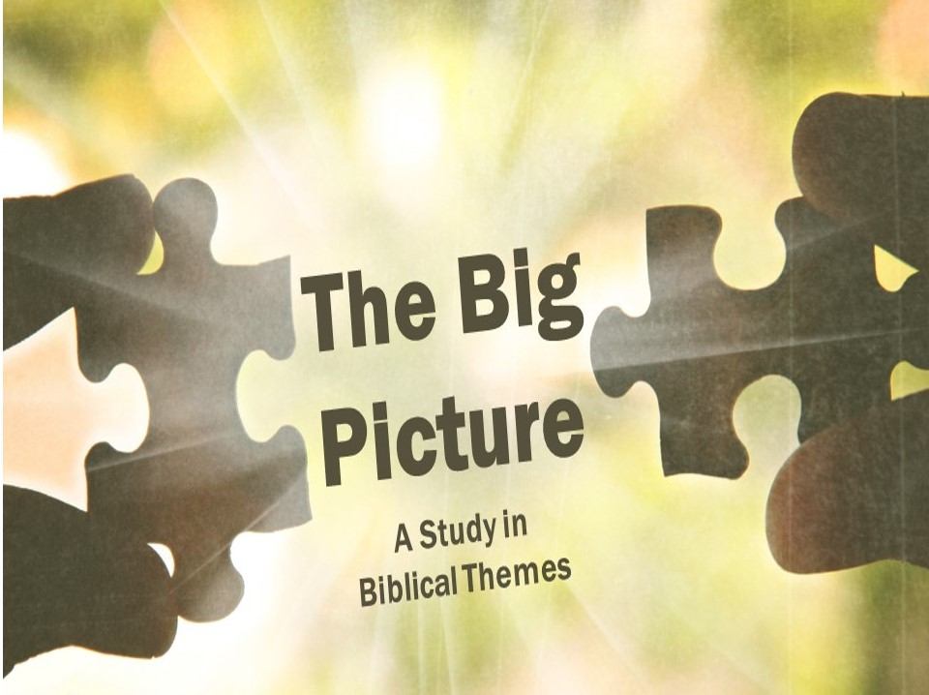

Lesson 3 - The Seed and the Snake

Note to the Teacher: This lesson involves more theology and grammar than are typically included in these lessons. As will become evident, however, the rest of Scripture builds on this theme, and seeing how the Old Testament and the New Testament refer back to what is taught in this lesson will help believers see important connections in their Bibles and appreciate the wisdom of God in his plan of salvation.
Sometime it can be helpful to have a movie summed up succinctly in one or two sentences. For example:
- Lord of the Rings: Group spends 9 hours returning jewelry.
- Lion King: An uncle kills a child’s father, so a pig and a big rat help him get his revenge.
- The Incredibles: Man’s midlife crisis endangers his family and entire city.
- Star Wars: Episode V: Talking frog convinces son to kill his dad.
- Star Wars: Episode VI: Father reunites with long lost son, wants him to take over the family business.
- Finding Nemo: Depressed widowed father teams up with mentally challenged woman to find his disabled son.
- Elf: Immigrant adoptee is repatriated to country of birth, experiences culture shock & prejudice.
- Babe: Talking bacon.
As humorous as these might be, it can be helpful to summarize a story in a sentence or two. Certain websites, like Cliff Notes, exist to simplify the main ideas of a book so that all the details make sense in light of the whole picture. Does the Bible ever do this? Does the Bible ever give us a one or two sentence summary of its contents?
Ask your group if they can think of any verses that might give the big picture of the Bible in a single verse.
John 3:16 is the first verse most people think of along these lines. This verse is the most famous in all the Bible, and for good reason. It sums up the story of the gospel in one sentence. But what about the Old Testament? Is there a verse in the Old Testament that sets up the entire story? That condenses the whole message of the Bible into a sentence or two? If so, does the New Testament ever point back to this verse?
Genesis 3:15, the verse in which God curses the serpent, sums up the entire coming conflict of the Bible. The ideas in this verse are developed in Genesis, then the rest of the OT, and finally in the NT itself. Theologians have called this the protoevangelium, a fancy word that means the first gospel. In this one verse we have a prophetic judgment that hints at the coming conflict we find in the rest of our Bible.
Read Genesis 3:15 together. Ask your group what this verse has to do with the gospel. Ask if they can think of any other places where this verse might be hinted at in the Bible.
Family Feud
What are the three parts of the verse? What three different pairs are given in each of those three parts? (the serpent and the woman; the serpent’s seed and the woman’s seed; it(he) and the serpent)
- The Serpent vs the Woman
The 1st section of this verse addresses the snake and the woman directly, following up on what has just happened in the story. Eve and the Serpent are now hostile towards each other, and rightfully so! But it’s in the 2nd and 3rd parts of the verse where things start to get really interesting.

- The Serpent’s Seed vs the Woman’s Seed
In the 2nd part of the verse, God states that there will be an ongoing hatred between the seed (or offspring) of the woman and the seed (or offspring) of the serpent. But is this referring to one of Eve’s future descendants, or all of them? There is some important wordplay going on here, but in order to understand it we need to take a close look at the Hebrew word translated “seed” (zera’). Much like our English word “offspring (descendant),” this word can be singular or plural. If I said, “I am having lunch with my offspring,” other than thinking that was an odd thing to say, you wouldn’t know whether I was eating with one of my children or all of them (assuming I had more than one child). We don’t say “offsprings,” because the plural of offspring is offspring. Likewise, the plural of zera’ (seed) is zera’ (seed). Which means we are still left with the question...

Does seed in this verse mean many of Eve’s descendants, or just one? Why do you think that?
The surprising answer is yes. The Bible goes on to describe the true children of the woman and the children of the serpent as being in conflict. But…
- The Seed vs the Serpent
…the final section in this verse points to something narrower – a one on one, costly fight between the Ultimate Offspring and the Serpent himself. “It” could also be translated “he” here, and this verse is picked up by later writers of the Bible to be a prophecy of the coming conflict between Christ and Satan himself. We’re going to take the next two lessons to unpack the importance of this hostility. This week we will look at the battle between the seed (plural) of the woman and the seed (plural) of the serpent, and in the coming weeks we will look at the battle between the Seed and the Serpent himself.
Who’s Your Daddy?
Some argue that reading a lengthy battle between the descendants of the serpent and the descendants of the woman is reading too much into this passage. They argue: “This is a verse about women and snakes. All we learn from this verse is that the relationship between mankind and animals has broken down, and you would understand that much better if you shared a desert with deadly snakes everywhere!” The problem with this view is that the later writers of the Bible pick up on this verse and refer back to it, as we will see.
- The Serpent Is More than a Snake
But who are the offspring of the serpent? After all, we don’t read about snakes attacking people (that often) in the Bible. So where do we see this battle between the offspring taking place?

Who are the seed of the serpent? Can you think of anyone in Scripture who is described this way?

In order to solve this, we need to realize that “the serpent” in this passage is later interpreted by Scripture as being none other than Satan, the devil himself.

Read Revelation 20:2. What in this passage specifically points back to Genesis 3:15? (note he is called “the old [ancient] serpent”)

- Satan’s Children Are Those Who Follow His Ways
So how do we know who Satan’s children are? Jesus gives us an important clue:

Read John 8:44. What in this passage points back to Genesis 3:15? (“from the beginning”)

How did the Jews in this passage end up as the children of Satan, even though they were sons of Abraham?

How does Jesus describe the children of Satan? (note: Satan is a murderer, and in 8:59 this crowd tries to murder him)
Those who follow Satan’s lead end up “becoming” his children, even though ethnically they are sons of Abraham! This point is repeated in 1 John 3:8, where we are told that those who sin are of the devil. Who was the first person to be “of the devil” you might ask? Well, 1 John 3:12 tells us it didn’t take very long for Satan to bring people over to his side?

How could John speak of Cain, the very first descendant of Eve, as being “of the wicked one”?
According to the Bible, you are on one side of the fence or the other; there is no in between. You are a child of God or a child of the devil. You are the offspring of the woman or the offspring of the devil.

A Battle for the Ages
This battle that begins in Genesis 3 is silently happening all throughout the book, if only we look for it.
- How the Bad Guys Fight
As we read Genesis, most of us know what’s going to happen. There will be Abraham, Isaac, and Jacob. Jacob will have 12 sons and Joseph will go to Egypt and save the family. But pretend you don’t know all that. Go back and read through Genesis waiting and looking for the Seed, and what you will discover is that there are a lot of close calls where the Seed is almost cut off. God narrows where the Seed will come from – Abraham, then Isaac, then Jacob, but there are many situations where it looks like sin or natural circumstances will be the end of the seed.
In what ways does the book of Genesis show Satan “attacking” the seed (the descendants of Eve)?
What problems present themselves that threaten to end the special family line?
How can understanding this be a comfort to believers living in 21st century America?
These two families are locked in a perpetual battle: the seed of the serpent (or Satan) and the seed of the woman (or the children of God). The serpent and his offspring hate the woman and her offspring, and so they seek to destroy the seed of the woman, especially if they can keep the Ultimate Seed from coming (more on this in the following weeks!). But that should raise the question for us, how does God want his children to respond?
- How the Good Guys Fight
Read Matthew 5:43-45. Why does the Bible teach that believers should have this type of response to unbelievers?
How does this square with God’s justice?
We are called to love fellow man, even as we war against the dark spiritual forces behind them (Ephesians 6:12). We are in a battle, but God promises us that he will ultimately be victorious (Romans 16:20).
How does Ephesians 6 teach us to fight against the dark forces behind the wickedness of the world that we see?
Switching Teams
Scripture teaches that we all begin as children of the serpent. Imagine how shocked the pious Jews of Jesus day were to learn that rather than being the seed of Abraham, they were of their father the devil! The good news, however, is that although all of us are originally born into Team Snake, we can switch teams. Several passages describe how this process can happen.
Read Galatians 3:26-29. According to this passage, how does this passage present us “changing teams”?
Using a slightly different image (citizenship rather than family), Colossians 1:12-14 describes the same process.
According to this passage, what is the most important part of our changing from the kingdom of Satan to the kingdom of God?
There is a war going on. The serpent and his offspring are warring against the offspring of the woman (later narrowed to Abraham). Everyone here is on one side or the other. This is the battle set up for us in the beginning of our Bibles that runs continuously throughout its pages, and continues just under the surface of everyday life. It is a battle that was ultimately fought between the serpent himself and the greatest Seed of the woman to ever be born, but that will be our focus in the coming weeks.
How can this lesson be an encouragement for believers?
Why don’t we see all of life as a spiritual battle?
How should this lesson affect the way we interact with unbelievers?

These were taken from a hashtag on Twitter: #explainafilmplotbadly It might be fun to try and get your group to figure out the movie, if there is a chance they have seen them.
The KJV translation has “it shall bruise thy head” but virtually all modern translations have “he shall bruise thy head” (NKJV, NASB, ESV, NIV, CSB). Both are possible from the Hebrew. The King James translation means that “it” (the seed) will bruise the serpent, and leaves open the question whether “seed” is singular or plural. The modern translations make the decision for the reader and say “he.”
See, for example, the note in the NET Bible version, available online for free at https://netbible.org/bible/Genesis+3.
There are a couple of ways to understand the phrase “as many of you as were baptized” that keeps us clear of the dangerous teaching of baptismal regeneration. (1) This could be a reference to Spirit baptism (cf 1 Corinthians 12:13) (2) In biblical times baptism always occurred immediately when one was converted to Christ, so that “becoming a Christian” and “being baptized” were virtually synonymous, even though one is not saved by being baptized.

