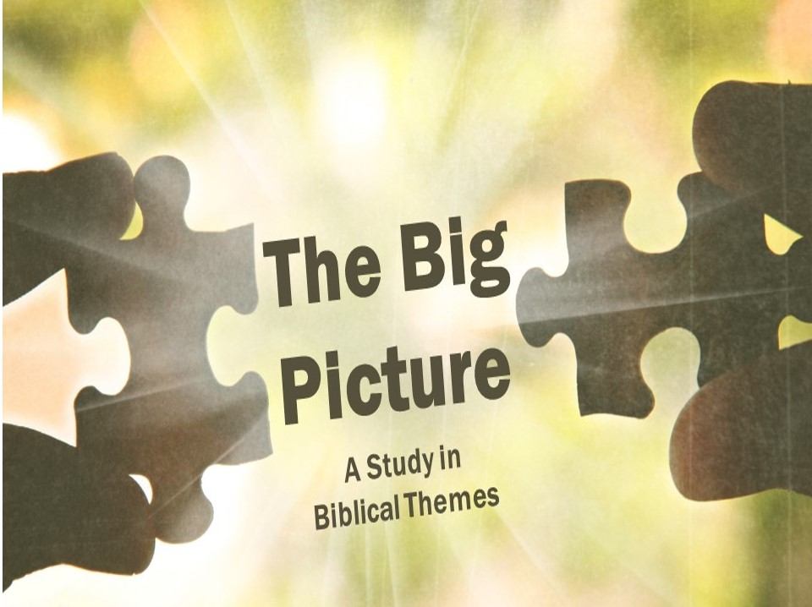

The Snake and the Seed
If you were to pick one verse that summed up the whole story of the Bible, which would you choose? In the Old Testament, God’s curse to the serpent gives hints as to how the rest of the story of the Bible will play out, a story we will be examining in the next few lessons.
Family Feud
- The ____________ vs the ____________
Not surprisingly, Eve and the Serpent are now mortal enemies. But what comes next gets interesting…

- The Serpent’s ___________ vs the Woman’s ___________
The Hebrew word for seed (zera’) can be either plural or singular. When describing the seed of the woman and the seed of the serpent, it is probably plural. These two groups will be at war. But...

- The ____________ vs the ____________
… in the final section when it switches to the serpent, the seed is probably supposed to be understood as singular. The Serpent vs the Ultimate Seed (descendant).

Who’s Your Daddy?
As we consider the middle part of this verse, the battle between the woman’s descendants and the serpent’s descendants, we have to ask who the children of the serpent are.
- The Serpent is more than a ____________
Revelation 20:2 makes it pretty clear that the serpent is none other than the devil himself.

- Satan’s ____________ are those who follow his ways
Jesus (John 8:44) and John (1 John 3:8, 12) make it clear that whoever sins and disobeys God puts themselves on Team Snake. Unfortunately, that means we all start off there.

A Battle for the Ages
- How the ____________ Guys Fight
The rest of the book of Genesis describes the Serpent and his offspring seeking to destroy the seed of the woman so that they ultimate seed will never come.

- How the ____________ Guys Fight
We fight as God would have us to fight – by putting on the gospel armor (Ephesians 6:10ff) and by loving our enemies rather than hating them (Matthew 5:43-45).

Switching Teams
The Bible teaches that we all begin on Team Snake, but the good news is you can switch teams! By trusting in Christ, Galatians 3:26-29 and Colossians 1:12-14 teach how you can have a different family and belong to a different kingdom!

