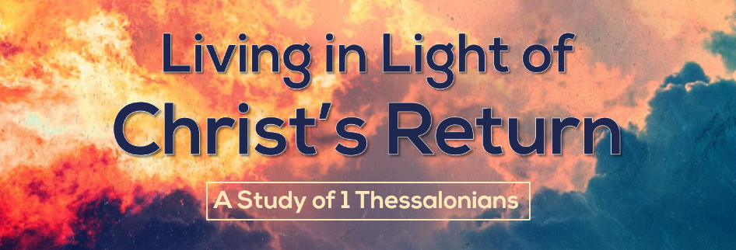

The Example of Your Love and Life
1 Thessalonians 4:9-12
How should we respond to unbelievers when they mock and malign us? How should we respond to other Christians with whom we disagree, and at times disagree strongly? What should our relationship with those outside these four walls look like? These are the questions and problems that Paul seeks to address with this passage. Tonight we are going to see that believers should set an example with their love and their life.
- You should live in love toward your brothers and sisters.
“I love you” tend to be pretty loaded words these days. Using them in the wrong context can be slightly awkward, but Paul uses this loaded term to describe believers relationship to each other.

- Christians are taught by God to love.
- God’s Word teaches us how to love others.
The Bible ultimately is what teaches us what God wants. And we find much in the Bible about how we are to love other people (John 13; John 15:12-17).

- God’s Spirit shows us how to love others (Galatians 5:22; 1 John 4:19).

- Christians should show their love broadly.
How did those in Thessalonica love all the brothers in Macedonia (North Greece)? Macedonia was an area probably not a whole lot smaller than the state of Indiana. Can you imagine someone saying “You have loved all the Christians in Indiana?” What does that mean? What did it look like?
- Putting up traveling Christians.
- Financially supporting other churches.

- Christians needs to continue growing in their love.
This is perhaps an odd way to end. Paul says, “You guys are doing great! Now keep doing better.” We should never become content in our Christian walk, we should always want to improve.

- You should live in integrity toward a watching world.
- Believers should live peaceful lives.
- Paul said to live peacefully (Romans 12:18)
- Peter said to live peacefully (1 Peter 2:12).
- Christ demonstrated living peacefully (John 18:33-40)
The gospel is a divisive message, but the way we present it and the way we live shouldn’t be divisive.
- Believers should live diligent lives.
Apparently, there were some lazy people at Thessalonica (cf 1 Thessalonians 5:14; 2 Thessalonians 3:6-12). Who were likely free loading off of other Christians. God wants believers to help each other, but it looks really bad when people take advantage of that kindness.

