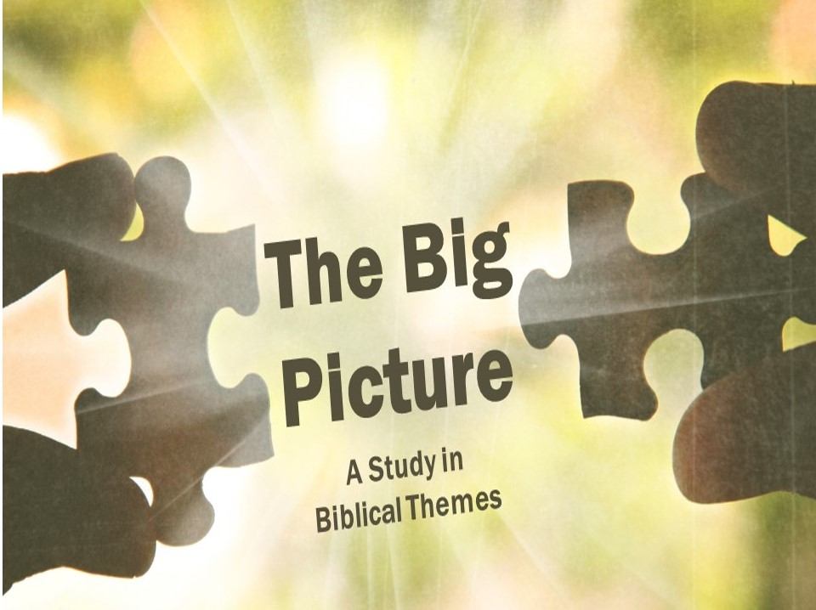

The New Covenant
If Israel broke God’s covenant with them over and over, how did God respond? What did he do to his rebellious people? Rather than destroying them, or ignoring them, or just starting over, he promised to make a new covenant with them. One that they wouldn’t break because they couldn’t break.
- The _______________ of the New Covenant (Jer 31:31-34)
- New ___________ to obey God’s law (33a)
God promised that when he entered the New Covenant with Israel that his law would be written on their hearts.
- A renewed _______________ with God (33b-34a)
God reiterates the special relationship he had promised to have with his people when he first delivered them from slavery (Exodus 6:7), despite their unworthiness. He also promises that there will be a deeper and more pervasive knowledge of him.
- _______________ of sins (34b)
God promises, finally, that he will forgive the sins of Israel.

- The _______________ of the New Covenant
This great covenant that God had promised Israel was coming has now come, at least in part.
- Jesus _______________ the New Covenant
When Jesus came, he inaugurated (or began) the New Covenant by his death on the cross. He announced the beginning of the new covenant during the last supper the night before he died (Luke 22:19-20, 1 Corinthians 11:25).
- The Spirit _______________ the New Covenant
So what about us Gentiles? If this covenant is with Israel, does it apply to us? Paul answers that Gentiles originally weren’t a part of the covenant with Israel, but they were included later (Romans 11:17). Scripture calls this a mystery – something that was not known in the Old Testament that God has revealed in the New Testament (Ephesians 3:4-6).

- The _______________ of the New Covenant
Not everything that is promised to Israel has happened, in fact, Israel has pretty much rejected this deal! So when will this happen?

- Israel’s _______________ to God (Romans 11:25-27).
Paul wants his readers to know that this isn’t the final word for Israel. God isn’t done with them; they will still enjoy the blessings promised in Jeremiah 31 yet. One day Israel will see Christ, and they will mourn for him whom they have pierced (Zechariah 12:10).
- God’s established __________ (Revelation 20:4-10)
Finally, God will fulfill the spiritual and the physical promises he made in the Millennium and then ultimately in the eternal state. Our hope is that the New Covenant has begun to be filled, and that it will one day be here in its complete entirety with no sin, suffering, or separation from God.

The New Covenant
If Israel broke God’s covenant with them over and over, how did God respond? What did he do to his rebellious people? Rather than destroying them, or ignoring them, or just starting over, he promised to make a new covenant with them. One that they wouldn’t break because they couldn’t break.
- The _______________ of the New Covenant (Jer 31:31-34)
- New ___________ to obey God’s law (33a)
God promised that when he entered the New Covenant with Israel that his law would be written on their hearts.
- A renewed _______________ with God (33b-34a)
God reiterates the special relationship he had promised to have with his people when he first delivered them from slavery (Exodus 6:7), despite their unworthiness. He also promises that there will be a deeper and more pervasive knowledge of him.
- _______________ of sins (34b)
God promises, finally, that he will forgive the sins of Israel.

- The _______________ of the New Covenant
This great covenant that God had promised Israel was coming has now come, at least in part.
- Jesus _______________ the New Covenant
When Jesus came, he inaugurated (or began) the New Covenant by his death on the cross. He announced the beginning of the new covenant during the last supper the night before he died (Luke 22:19-20, 1 Corinthians 11:25).
- The Spirit _______________ the New Covenant
So what about us Gentiles? If this covenant is with Israel, does it apply to us? Paul answers that Gentiles originally weren’t a part of the covenant with Israel, but they were included later (Romans 11:17). Scripture calls this a mystery – something that was not known in the Old Testament that God has revealed in the New Testament (Ephesians 3:4-6).

- The _______________ of the New Covenant
Not everything that is promised to Israel has happened, in fact, Israel has pretty much rejected this deal! So when will this happen?

- Israel’s _______________ to God (Romans 11:25-27).
Paul wants his readers to know that this isn’t the final word for Israel. God isn’t done with them; they will still enjoy the blessings promised in Jeremiah 31 yet. One day Israel will see Christ, and they will mourn for him whom they have pierced (Zechariah 12:10).
- God’s established __________ (Revelation 20:4-10)
Finally, God will fulfill the spiritual and the physical promises he made in the Millennium and then ultimately in the eternal state. Our hope is that the New Covenant has begun to be filled, and that it will one day be here in its complete entirety with no sin, suffering, or separation from God.

