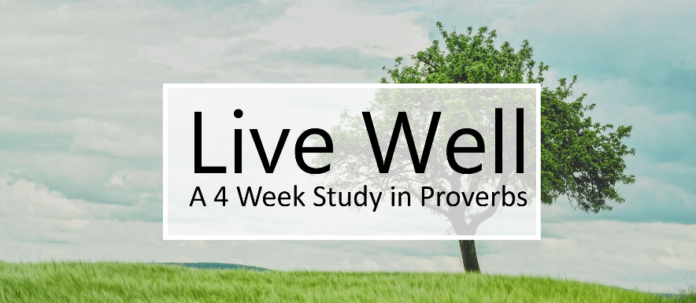

Lesson 1 – Don’t Be Dumb!
There are certain things we all know we are not supposed to do. There are certain things we are told we must do. But many of the commands of the Bible require skill to apply well. And much of our lives are lived outside of this list of do’s and don’ts. In these situations we need wisdom.
What is wisdom?
Wisdom is based on knowledge (Proverbs 1:1-7)
The many different synonyms used in these first few verses highlight different aspects of smart living on God’s planet.
Wisdom observes the world (1 Kings 4:32-33; Proverbs 8:22-31)
Wisdom can describe what we would think of as scientific pursuits, because the God that made the physical world made the spiritual world as well.
Wisdom is a type of skill (Exodus 31:1-3; 36:1)
The Hebrew word for wisdom can describe a skilled artisan, because wisdom involves applying the knowledge I have.
Definition – An understanding of how life works that allows me to skillfully make right choices.
Why should you want wisdom?
Wisdom will allow you to live successfully (Proverbs 3:1-10, 13-18).
Wisdom will keep you from great danger (Proverbs 3:21-26).
Wisdom will enable you to live through tragedy and disappointment (Ecclesiastes and Job).

How do I get wisdom?
There are 3 possible sources of wisdom that Scripture teaches us about.
Self (Proverbs 3:5-7; 12:15; 26:12) God frequently warns about the dangers of listening to one’s own heart for wisdom.
Creation (Proverbs 6:6) Because God made both the physical and spiritual dimensions, observing the physical can give us wisdom for the spiritual.
The World (1 Kings 10; James 3:13-18) While the wisdom literature is some of the most universally applicable, we must be careful when listening to the world, because they have the wrong starting point and often end up with the wrong answers.
God (Proverbs 3:5-6) Fearing God is what will ultimately lead to wisdom (Proverbs 9:10; Job 28:28; Psalm 111:10). God gives us wisdom through 3 avenues:
    - His Word (Proverbs 1:1-7)
    - Prayer – (James 1:5)
    - Wise people – (Proverbs 13:20; 11:14; 24:6)

