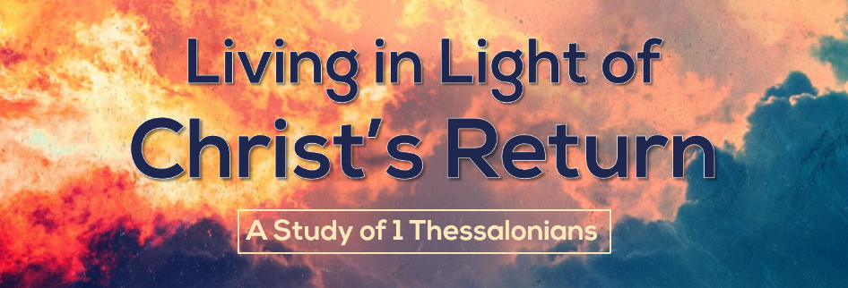

Live Consistently
1 Thessalonians 1:8-10
When people look closely at your actions, do they support or undermine your gospel witness? We have a message to bring to a watching world that will either be reinforced by our behavior, or contradicted by it. If we want to be effective in our evangelism, we have to ready to show from our lives that we really believe what we say we believe.
Your life validates your message, so live consistently.
- Live consistently by prioritizing God’s Word (cf Acts 17:5-9).
- Prioritize God’s Word by receiving God’s message.
The reception the Thessalonians gave to Paul and his associates demonstrated their attitude toward the message.
- Prioritize God’s Word by standing for God’s message.
Jason and his friends were dragged before a council and threatened. Jason even had to pay bail. Taking a stand for God’s Word today, although it rarely threatens legal consequences, can still be a costly choice.

While you may not put up traveling preachers, your actions still demonstrate how seriously you take God’s Word.
- Do you read God’s Word regularly?
- Do you attend the preaching of God’s Word faithfully?
- Do you give money for the spread of God’s Word sacrificially?

- Live consistently by submitting to God’s authority.
- Believers must turn from idols.
Turning from idols was a huge sacrifice on the part of early Christians. At the time, politics and religion were so tightly interwoven that to abandon the state religion was almost viewed as treasonous.

- Believers must turn to God.
You will always submit to someone or something. Living under no one’s authority isn’t possible. You will either serve God, or serve idols.

- Live consistently by waiting for Christ’s return.
- Christ’s is coming from heaven.
Christ said in John 14 that he is going to prepare a place for us so that we can be with him in heaven. How excited are you to go and live with Christ forever?

- Christ’s coming saves us from God’s wrath.
Because Christ took the punishment of our sins, we don’t have be afraid of Christ’s return. We can look forward to it with joy!

