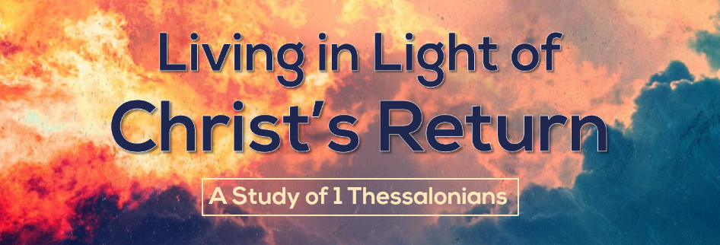

Holy Living in a Sex Crazed World
1 Thessalonians 4:1-8
According to a Barna study put out in 2018 only 19% of millennials and 21% of Gen Z thought that sex before marriage is morally wrong, about 1/5 of the population. Barely more than a third of that age group thought that marriage should be a lifelong commitment between a man and a woman. The good news is that of engaged Christians in Gen Z, 76% belong that sex before marriage is wrong. Christians are holding the lines in the corrupt culture we live in.
The city of Thessalonica was a pretty debauched place. One commentary relates the following story of the god Bacchus (the Roman equivalent of the Greek god of wine Dionysius): “I had drunk my fill of undiluted water, when Bacchus stood beside my bed, yesterday, and spoke thus: ‘You sleep the sleep of those whom Aphrodite hates; tell me, my sober friend, have you heard of Hippolytus? You should be afraid of suffering a fate like his.’ Thus he spoke, and went away; and since then water is no longer any pleasure to me.” In the archeological excavations of the city we have discovered one of the main cult objects of the city was the phallus. According to the same commentary “The phallus was honored and even borne aloft in processions. In the worship of Dionysus . . . the phallus was revealed and carried in processions with appropriate hymns intoned to it.”
It is to this city where the goddess of sex gets upset when men don’t get drunk and male parts have hymns sung to them that the gospel of Jesus Christ establishes a foothold. When these Thessalonians turned “to God from idols to serve the living and true God,” it was a culture shock. And yet apparently the break wasn’t as clean as it needed to be. Some of them still struggled with living an immoral lifestyle.
- Holiness is the end goal of our behavior.
The word that Paul uses to describe the goal for the believers in this passage is the Greek hagiasmos, which is translated as “holiness” or “sanctification.”
- Holiness focuses on God, not on self. Too often we focus on “purity.” While this passage does mention impurity, the word that the Holy Spirit uses over and over is the word “holiness.” Purity can very quickly become self-focused, whereas holiness implies being set apart from sin to God (cf 1 Thessalonians 1:9).
- Holiness never stops being a goal. Paul encourages the believers in Thessalonica that they were doing right, but that there was room to grow. No doubt he is thinking of them as a group, but as individuals it is also important that we realize that God wants us to continue to grow in holiness. None of us have made it yet!

- God has clearly revealed his desire for holiness.
- Christ has set the standard for holiness. Twice Paul reminds the Thessalonians that his commands did not come from himself, but rather that they were from Christ himself (“in/through the Lord Jesus” vv 1, 2). No doubt Paul and his associates had taught the Thessalonians the high standard that Christ gave in his sermon on the mount (Matthew 5:27-30).
- Holiness pleases God. God cares about our actions. He is pleased and he can be displeased by our behavior. Holy living is a chance to bring joy to our heavenly Father or be a grief to him. Those who love God will fight sexual sin.
- Holiness is the will of God. There are few things that we are told explicitly are the will of God. Often we want to know what God’s will is for our lives, and typically by that we mean what big decisions we should make. God is normally talking about what commands he wants us to obey. If we won’t obey what God has revealed in his Word, why would he reveal to us his will outside his Word? And if he did, would we obey it?

- Holiness requires self-control.
The ability to say no to our desires is a necessary part of growing in Christ. This process happens as God’s Spirit works in our lives (Gal 5:22-23) and as we work at it (1 Cor 9:27).
- God expects us to live in self-control. Paul tells the believer’s to gain mastery over their own desires. It is easy to be ruled by our desires; it is very hard to rule over them. Our body should be under our control, they should not control us.
- God demands that we not live according to our passions. The opposite of this is to allow one’s passions to control them. This is how unsaved people live. As one author put it “The idea that desire equals license comes factory-loaded in all of us.” In other words, most people think if they want it, they deserve it. Christ calls us, however, to a higher standard. Christ calls on us to abandon our desires so that we can live for God (Matthew 16:24).

- Holiness affects those around us.
God threatens to bring judgment upon those who defraud a brother. Probably the main thing Paul is thinking of here is the husband or father who is defrauded in cases of adultery or immorality, but the point that our sexual sins hurt others has a much broader application today. The person we sin with is harmed as well, even if that person is on a screen.

- Holiness matters to a Holy God.
- Impurity brings about God’s wrath. As we saw above, God threatens to bring vengeance to all those who defraud others sexually. Not only that, but we see in other passages that he will bring judgment upon all of those who persist in this type of sinful behavior (cf 1 Corinthians 6:9-11; Ephesians 5:5-6). Knowing how angry this sin makes God should give us a healthy fear of him that motivates right living (Proverbs 1:7).
- Impurity separates us from God. Paul ends this section by reminding us that when we reject this teaching, we are rejecting the holy God who gives us his Holy Spirit. Those who choose to live immoral lives are rejecting the Holy Spirit who lives within them, a grievous sin that Paul elaborates on further elsewhere (1 Corinthians 6:19-20).

“Gen Z and Morality: What Teens Believe (So Far)” Oct 9, 2018. https://www.barna.com/research/gen-z-morality/ Accessed 3/13/19.
Gene Green. The Pillar New Testament Commentary: The Letters to the Thessalonians.
Jeffrey Kluger, “The Evolution of a Narcissist,” Time, September 1, 2014.

