Lesson 16
“Don’t Waste Your Prime”
Ecclesiastes 11:1-12:8
Youth is an incredible thing. If life is like a puff of smoke, here and gone in an instant, the prime youth of our life is like a tiny wisp of that life. Yet it holds incredible significance. Think of David, who took down Goliath as a boy or Daniel, who was likely a teen when he was taken to Babylon. Jesus’ disciples were probably young adults, yet they changed the world. Paul told Timothy not to despise his youth. God cares about this pivotal life stage

In the end of Ecclesiastes, Solomon encourages us not to waste the prime of our lives. Don’t squander your youth! This a pivotal time of your life, and it could be squandered in selfishness or embraced in reverence. Let’s look at the wisdom of Solomon as we seek to use our life well for God’s glory.

Steward Your Future Well (11:1-6).
- Work ahead with wisdom (vs. 1-2).
- Work ahead with a realistic view (v. 3).
- Work ahead without or excuses (v. 4).
- Work ahead with a sovereign understanding (v. 5).
- Work ahead with a diligent (vs. 6).

Other Notes:

Enjoy your Life Reverently (11:7-10).
- It’s good to be through every stage of life (vs. 7-8).
- It’s good to enjoy life on (v. 9).
- It’s good to get about youth while you have it (v. 10).

Other Notes:

Choose Godliness in Your Youth (12:1-8).
- Choose God in your while you have it (v. 1a).
- Choose God before you’re (vs. 1b-5a).
  - Your perspective could become cynical (v. 1b).
  - Your will be different (v. 2).
  - Your will be weaker (vs. 3-5a).
- Choose God before you (vs. 5b-8).

Other Notes:

Prayer
Scripture: ²⁴ Then said Jesus unto his disciples, If any man will come after me, let him deny himself, and take up his cross, and follow me. ²⁵ For whosoever will save his life shall lose it: and whosoever will lose his life for my sake shall find it. ²⁶ For what is a man profited, if he shall gain the whole world, and lose his own soul? or what shall a man give in exchange for his soul?
Matthew 16:24-26

College Student of the Night: All of Them
- Traveling Home
- Summer Jobs & Ministries
- Graduate Transitions

Single Focus/Cross Impact Requests:
- Single Focus (Connect, Grow, Serve)
  - College Student Welcome Home
  - Midwest Young Adults Conference
  - Community over the summer season
- Cross Impact IUPUI, Purdue, Ball State, and UIndy (potential at other campuses)
- Sunday Soul-Winning Efforts

Specific Requests:
- Jack Elms, Kendall Elms, Jesiah Achenbach, and Max Garcia in military training/service
- Joseph LaPointe’s back and spirit
- Jessica’s Unsaved friend in Mormonism
- Ian’s unsaved family
- James as he recovers from his diabetic episode and financial implications (Hau’s friend)
- Karen’s (Elizabeth’s coworker) continued complications from her surgery months ago
- Jessi Gold’s search for an internship.
- Pastor Jonah Scott (Andy’s friend in WI) still fighting the infection that caused sepsis. Lots of ups and downs right now: praying to be home by the end of June.

Announcements:
- College Student Welcome-Home event- May 17
- Midwest Young Adults Conference- June 1
- Midweek Connection Openers and Music Schedule

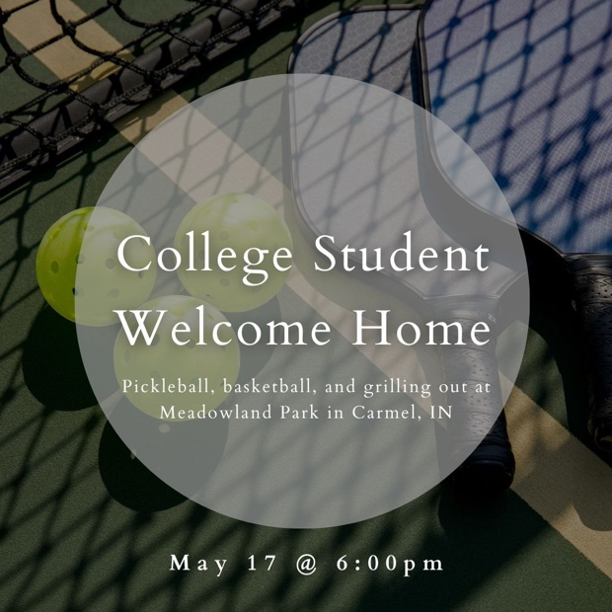

Order of Service for tonight:
- Opening Game: Your Mom
- Announcements:
- Opener: Andy
- Songs: John Barfield
  - Constrained by Christ – p. 141
  - To Live or Die (on screen)
- Prayer:
- Message: Pastor Andy

