Lesson 11
“How to Be Better Off”
Ecclesiastes 7:1-14

We're now diving into the second half of the book of Ecclesiastes. In the first half, Solomon shared his experiences 'under the sun,' trying everything only to find it all fleeting and vain. But now, he transitions from recounting his actions to imparting wisdom. What can we learn from his insights and experiences? In this section, Solomon emphasizes the concept of 'good' or 'better' eleven times, highlighting the brighter aspects of life. It's a passage focused on how to be “better off” by living according to Godly wisdom.

Consider life and death (7:1-4).
- A good is better than perfume (v. 1a).
- Your death-day is better than your (v. 1b).
- Mourning is better than partying (vs. 2, 4).
- Sorrow is better than (v. 3).

Other Notes:

Consider wisdom and foolishness (7:5-7).
- An unwanted rebuke is better than an attractive (v. 5).
- Compare the (vs. 6-7).
  - The fool’s message sounds nice, but it’s meaningless.
  - The wise man’s message sounds harsh, but it’s .
    - He is tempted to give up.
    - He is tempted to .

Other Notes:

Consider the past, present, and future (7:8-10).
- The is better than the beginning (v. 8a).
- Patience is better than (vs. 8b-10).
  - Pride leads to outbursts.
  - Pride leads to foolish .
Other Notes:

Consider wisdom and money (7:11-12).
- Both are profitable (v. 11).
- Both provide (v. 12a).
- But wisdom gives (v. 12b).

Other Notes:

Consider good times and bad (7:13-14).
- God all things (v. 13).
- We to His direction (v. 14).

Other Notes:

Prayer
Scripture: So teach us to number our days, that we may apply our hearts unto wisdom.
Psalm 90:12

College Student of the Night: Ryleigh Dawson
- Junior at PCC
- Prayer Requests:
  - Upcoming projects
  - Overall workload is greater this year (classes, job, etc.)

Single Focus/Cross Impact Requests:
- Cross Impact IUPUI, Purdue, Ball State, and UIndy
- Potential at IU, Marion, and Butler
- Single Focus (Connect, Grow, Serve)
- Sunday Soul-Winning Efforts
- Summer Missions Trip

Specific Requests:
- Jack Elms, Kendall Elms, Jesiah Achenbach, and Max Garcia in military training/service
- Joseph LaPointe’s back and spirit
- Jessica’s Unsaved friend in Mormonism
- Sarah’s family’s salvation
- Aaron Bott and family- Soldier in Kuwait (Joe Forti’s friend)
- Ian’s unsaved family
- James as he recovers from his diabetic episode (Hau’s friend).
- Elizabeth’s coworker who is recovering from surgery and needs to have strong recovery.
- Jessi Gold’s search for an internship.
- Luke and Delilah Howell (and the Pixley family)- Lost their baby this week.

Announcements:
- March Madness Bracket Challenge
- March 24- SNF- Meeting at the Montgomery’s House for the Kenosha Missions Trip
- Beef and Boards- April 12

Order of Service for tonight:
- Opening Game: Bracket Challenge
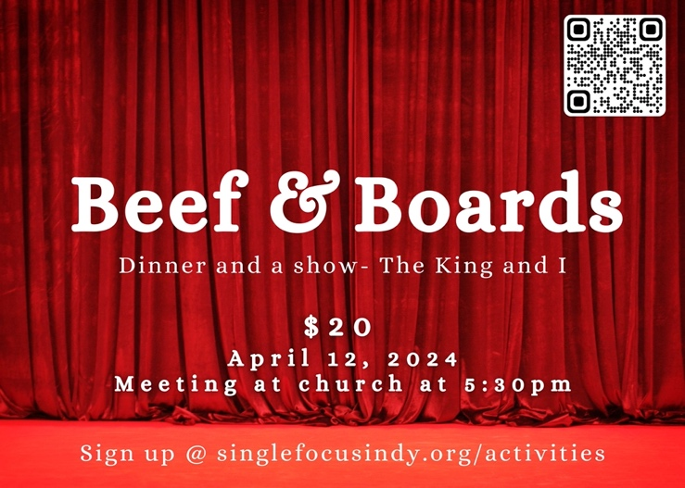
- Announcements:
- Songs:
  - Constrained by Christ (p. 141)
  - Walk Worthy (on screen)
- Prayer:
- Message: Pastor Andy

This sermon title came from Warren Wiersbe’s “Be Series” book on Ecclesiastes. “Be Satisfied.”

