Lesson 10
“Is Life a Dead End?”
Ecclesiastes 6:1-12

The wisdom books of the Bible provide insight into living the "Good Life" in reverence of God. While Job addresses the struggles of suffering within a seemingly good life, prompting deeper understanding of God's sovereignty through pain, the Psalms guide emotional and worshipful expressions, emphasizing meaningful meditation on God's truth. Proverbs offers wisdom and principles for wise living and its consequences, while the Song of Solomon explores the dynamics of a good life within marriage.

However, Ecclesiastes challenges the notion of the good life, asking the question, “It is even attainable?” This book is a contrast between life “under the sun” and life in the fear of God. Is there really such a thing as a good life? Or does it all just lead to a dead end. In chapter 6, Solomon wrestles with the “under the sun” perspective to help us realize that without God, you cannot enjoy a meaningful life. With Him, you can.

You could have it all, yet not enjoy it all (6:1-6).
- Achievements can be (v. 2).
  - Massive can be wasted.
  - Tons of stuff can be wasted.
  - Great can be wasted.
- Accomplishments can be (vs. 3-6).
  - He is successful, but not satisfied (v. 3a).
  - He is successful, but not (v. 3b).
  - He is successful, but not (vs. 4-6).
    - The unborn stay (v. 4).
    - The unborn get to stay ignorant (v. 5a).
    - The unborn get to stay (v. 5b).
    - The unborn get to arrive (v. 6).

Other Notes:

You could pursue satisfaction, yet not attain it (6:7-9).
- Good doesn’t totally satisfy (v. 7).
- Good wisdom doesn’t totally satisfy (v. 8).
- Good don’t totally satisfy (v. 9).

Other Notes:

You could seek answers, yet not find them (6:10-12).
- You cannot change (vs. 10-11).
- You cannot comprehend all of life (v. 12a).
- You cannot the future (v. 12b).

Other Notes:

Prayer
Scripture: For my thoughts are not your thoughts, neither are your ways my ways, saith the LORD. For as the heavens are higher than the earth, so are my ways higher than your ways, and my thoughts than your thoughts.
Isaiah 55:8-9

College Student of the Night: Colin Elms
- Sophomore at PCC
- Prayer Requests:
  - Finishing up midterms
  - Travelling back to Indy for Easter

Single Focus/Cross Impact Requests:
- Cross Impact IUPUI, Purdue, Ball State, and UIndy
- Potential at IU, Marion, and Butler
- Single Focus (Connect, Grow, Serve)
- Sunday Soul-Winning Efforts

Specific Requests:
- Jack Elms, Kendall Elms, Jesiah Achenbach, and Max Garcia in military training/service
- Joseph LaPointe’s back and spirit
- Jessica’s Unsaved friend in Mormonism
- Sarah’s family’s salvation
- Aaron Bott and family- Soldier in Kuwait (Joe Forti’s friend)
- Ian’s unsaved family
- James as he recovers from his diabetic episode (Hau’s friend).
- Elizabeth’s coworker who is recovering from surgery and needs to have strong recovery.
- Jessi Gold’s search for an internship.

Announcements:
- March 24- SNF- Meeting at the Montgomery’s House for the Kenosha Missions Trip
- Beef and Boards- April 12 (more details to come)
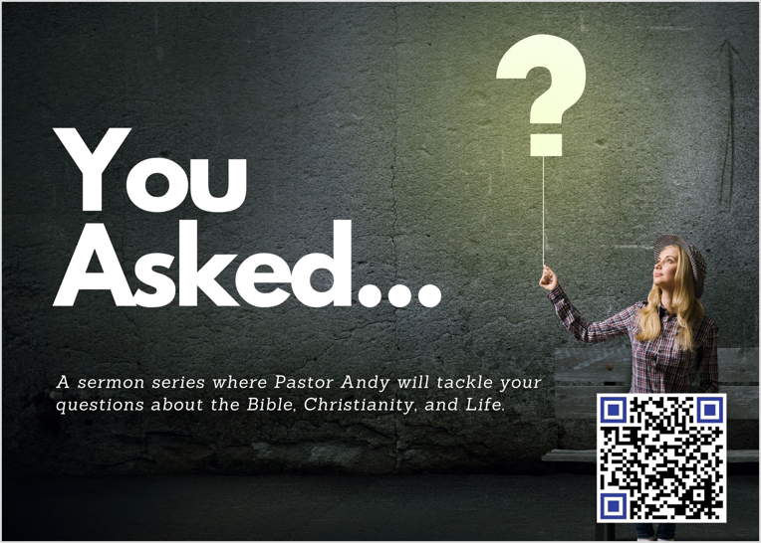

Order of Service for tonight:
- Opening Game: Feeling Green
- Announcements:
- Opener: Andy
- Songs:
  - Higher Ground (on screen)
  - Complete in Thee (on screen)
- Prayer:
- Message: Pastor Andy

