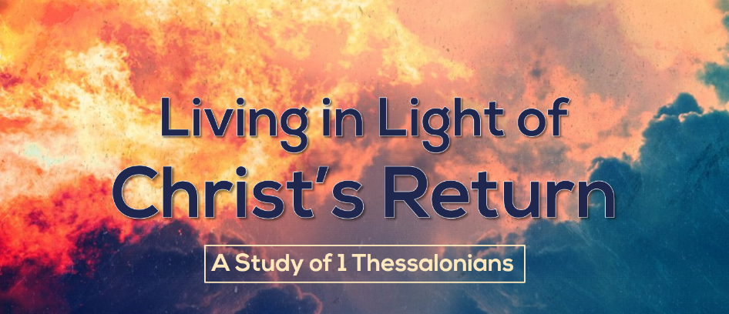

1 Thessalonians is one of the earliest letters Paul wrote, and one of the earliest letters of our entire New Testament. In it Paul rejoices over the good news he had received that the church he had planted was enduring persecutions, and then sought to address the areas of concern that had arisen. This letter gives us a glimpse into the heart of a discipler, and reminds us of the importance of being ready for Christ’s imminent return.
History of 1 Thessalonians
- Paul planted the church in Thessalonica on his second missionary journey (Acts 16-18:23).
- Paul was called to go to the area of Macedonia (modern day Greece) and there he visited Philippi and was persecuted and run out of town (Acts 16:11-40)
- After leaving Philippi, Paul planted a church in Thessalonica (Acts 17:1-4)
- Unfortunately, persecution caused him to leave the church sooner than he had wanted to (Acts 17:5-9).
- Paul went on to Berea and later Athens and Corinth, but the whole time he was concerned about how the believers in Thessalonica were doing (1 Thessalonians 3:1-2).
- Timothy brought a good report, and this excited Paul and became the motivation for writing 1 Thessalonians (1 Thessalonians 3:6).
Outline of 1 Thessalonians

- Paul Remembers (1-3)
- How the Church was born (1)
- How the church was nurtured (2)
- How the church was established (3)

- Paul Exhorts (4-5)
- In holiness (4:1-8)
- In harmony (4:9-10)
- In honesty (4:11-12)
- In hope (4:13-5:11)
- In helpfulness (5:12-28)

Problems with the Thessalonian Church
By reading the letter that Paul wrote carefully, we can pick up some of the problems that he was addressing in the church, despite an overall positive report on the church.
- Attacks on the character of Paul undermining his motives and sincerity.
- Confusion regarding the Day of the Lord, especially concerning 1) what happened to believers who died and 2) believers not working since they thought the rapture was soon.
- The constant temptation to immorality that was present in much of the Roman Empire.

Themes of 1 Thessalonians
Ministry
Paul reminds and describes what the ministry he had in Thessalonica was like. In response to those who attacked him unfairly, Paul simply reminded the church of their history.
- Sincere – Paul was not a cheat or a swindler. His motives were pure and his ministry honest (2:3-6, 10).
- Scripture-saturated – Paul was not giving his message, he was giving God’s message (1:6-8; 2:13).
- Spirit-empowered – Paul realized that the success of his ministry ultimately lay with God’s power, not his presentation (1:5-6).
- Sacrificial – Paul reminded the Thessalonian believers of the fact that he came from persecution, endured more persecution, and worked hard to pay his own way to present the gospel (2:2, 9; 3:7).
- Sentimental – Paul cared deeply for these believers and was open about his deep care and love for them (2:7-9, 11-12).

Eschatology
Paul develops the teaching of the end times – Christ’s return and all that comes with it – in several places throughout the letter.
- Every chapter ends with a reference to the second coming of Christ (1:10; 2:19; 3:13; 4:13-18; 5:23), and there is an extended discussion of Christ’s return in 4:13-5:11)
- Paul doesn’t outline for us in chronological order what he believes about the end times as we might like him to. Rather, he deals with eschatology as it comes up in his pastoral discussion.

- We should seek to understand how all these details fit together, but not at the expense of seeing what eschatology means for us!
  - We should rejoice because of Christ’s coming (1:10).
  - We should be preparing for Christ’s coming (2:19-20).
  - We should live a holy life in light of Christ’s coming (3:13).
  - We should be comforted by the thought of Christ’s coming (4:13-18).
  - We should be confident in light of Christ’s coming (5:23-24).

- “Paul did not look on this doctrine as a theory to be discussed, but as a truth to be lived.” - Wiersbee

Holiness
Paul spends a sizeable portion of the letter discussing the importance of holy, pure living in a perverted culture (1 Thessalonians 4:1-8). He argues that holiness, especially in regards to sexual purity, is the will of God and has grave consequences if disregarded.

1 Thessalonians is a letter that gives us a look into the heart of Paul and reminds us of Christ’s impending return and our need to live holy, diligent lives in light of that truth. It shows us how discipleship should be carried out: careful, practical teaching in the context of a strong, sacrificial relationship.

Taken from Wiersbe’s commentary on 1 & 2 Thessalonians: Be Ready.

