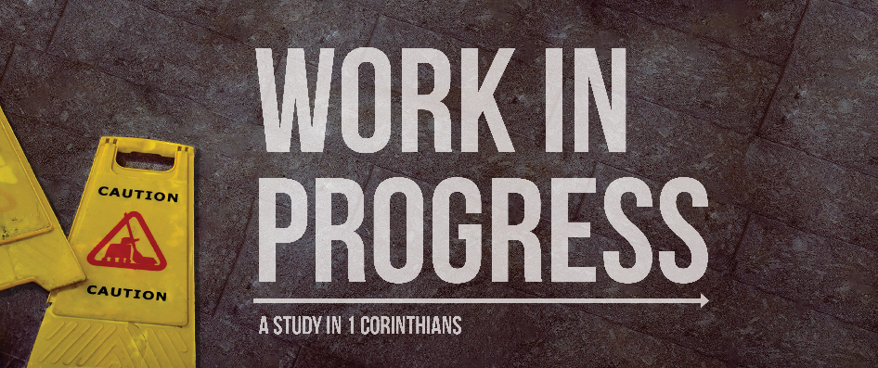
Welcome to Corinth!
Introduction to the Book
Are Christians hypocrites? One of the most common criticisms of Christians is that they hold to such high standards of morality in theory but that they are often mean, nasty, unkind, judgmental people. While Christians living short of the calling they have in Christ bring shame to God’s name, we must recognize that the gospel is for sinful people. The Bible teaches that at salvation, we are made holy in our standing before God, but then we must become holy in our practical conduct. When God takes sinful people and makes them holy people, it’s going to be a bumpy ride!
The church is not a museum for the perfect but a hospital for the sick. Christians have problems! God doesn’t want us to be content in our sins and our faults, but instead patiently works with us to address them. In our Bible, there is one book that stands out above all else as a book dealing with Christian problems. These Christians had problems in their personal lives and in their church life. They couldn’t get along with each other. They were dragging other Christians to court. They were struggling to live holy in a sex-crazed world. They viewed ministry as a way to get ahead personally. They were treating holy things with irreverence. They had allowed dangerous doctrine to creep in. Welcome to the church at Corinth!
Sometimes we have over idealized pictures in our mind of what the first century must have been like. We think that if Paul planted the church, and Paul was an apostle, then the church must have been a utopia. But that’s now how church works. Every church is imperfect people trying to grow to serve God better and live holier. Corinth was no exception, and watching Paul address their problems helps us know how to address ours.
Corinthians is a very important letter for us to study. In fact, it’s hard to overestimate the importance of this letter:
- More content written to Corinth than any other New Testament church.
- In his missionary travels, the only city Paul spent more time in than Corinth was Ephesus.
- 1 Corinthians shows us what the life of the church looked like more than any other letter.
- Few letters give us as much information as 1 Corinthians on the various issues of systematic theology (see below).
- Major doctrines are given the definitive treatment in this letter: the Lord’s Supper, church discipline, tongues and spiritual gifts, singleness, the resurrection.
Paul and the Church at Corinth… what did I miss?
Paul’s Beginning
Paul was a persecutor of the church who was saved when he met the risen Lord Jesus. He then spent three years in the desert of Arabia, likely preaching the gospel to those who were there, until a coalition of Jews and Arabians sought to kill him in Damascus. He then went to Jerusalem, and then to his home city of Tarsus, again likely evangelizing the area. Later, Barnabas needs help at the church in Antioch and goes and finds Paul and brings him to help. Paul and Barnabas are later commissioned to go spread the gospel, and they do so heading to Cyprus and then to Galatia (modern day Turkey). During this time, the explosive issue of whether or not Gentiles must become Jews in order to truly be saved rises and the church at Jerusalem decides that Gentiles do not need to become Jews.
Paul’s Second Missionary Journey
Paul then goes back to the churches at Galatia and to encourage them before heading out to new territory. Paul and crew are unsure where to go, until in a vision Paul sees someone from North Greece (i.e. Macedonia) calling out for someone to come. Paul and his team respond and plant a church in the city of Philippi. Then Paul and Silas are beaten and run out of town. They go to Thessolonica, and are once again run out of town by the Jews. Next they go to Berea, and believe or not, they are run out of town by the Jews. Paul comes to Athens alone, with Timothy and Silas both running errands in Macedonia, and preaches a powerful message that is partly ignored, partly mocked, and to which a few responded. When Paul leaves Athens, though things don’t seem to have been all too successful (while a church was likely planted, Paul moved on quickly and we never hear again about a church at Athens).
One commentator gave Paul’s departure from Athens and entrance into Corinth this perceptive description:
“He came to Corinth feeling weak in every way—physically battered, spiritually unexcited by the Athenian experience, emotionally deprived of the partnership of Silas and Timothy, and naturally rather in trepidation at the prospect of coming face to face with the city of love.”
Paul’s Trip to Corinth
The city of Corinth
- Corinth was huge. It was the largest city in Greece, probably the third largest city in the Roman empire behind Rome and Alexandria. It’s possible that this was the largest city Paul had ever visited by the time he got to Corinth. Population estimates range from 400,000 (roughly the size of Cleveland) to 700,000 (about the size of Boston) citizens. By ancient standards, this was a massive, massive city.

- Corinth was competitive. Corinth was wiped out in 146 B.C. by the Romans, and was rebuilt nearly a hundred years later by Julius Caesar in 44 B.C. When it was rebuilt, it allowed those who had wealth and ambition, but not necessarily connection, to make it big time. In addition, the city was strategically located on an isthmus – a small piece of land that barely connects a peninsula to the mainland. This meant that it was often easier and cheaper to carry goods going from Rome to the east through Corinth than to sail around the Peloponnese. In other words, there was a lot of trade, which meant a lot of wealth. The opportunity for wealth and the possibility of upward mobility led many to flock to Corinth. Rather than the American dream, we might think of it as “the Corinthian dream.”

- Corinth was cosmopolitan. Because Corinth was resettled people from all kinds of different backgrounds came, although the city still kept some of its strong Greek flavor. There was an openness to new ideas and perspectives that wouldn’t be as strong in a city that had a firmly entrenched ruling class and a way of doing things that went back hundreds or thousands of years.

- Corinth was thoroughly pagan. Multiple temples lined the streets of Corinth. Most notably, at the top of the large hill in Corinth was the temple of Aphrodite, goddess of love. While perhaps an exaggeration, the writer Strabo writing just before the birth of Christ describes the temple as employing 1,000 prostitutes. Eating in the temple of pagan deities was apparently so common some new believers didn’t see anything wrong with it, since those gods weren’t real anyway. As a port city, there was plenty of vice to go around in general.
And so into this pagan, ambitious, success-driven, immoral city comes a determined Jewish rabbi claiming that the Lord of the universe came to earth as a Jewish prophet, was executed on a cross, but is now alive again and calls upon all to believe in him and sacrifice for others as he has for them and live a life of purity and humility. What could go wrong?
Paul’s Time in Corinth
In Acts 18 we are given the account of Paul’s time at Corinth. We find that Paul immediately met Aquila and Priscilla (Prisca) who just happened to be Jews who worked the same trade and either were believers or soon became believers. When Timothy and Silas return from North Greece (Macedonia), they bring financial support and Paul goes into full time church planter mode. He stays in the city for at least 18 months, and is for once not run out of town by the Jews (although they do try). A church is planted, but a church that is going to have a bit of a rocky road ahead of it. Eventually Paul would go back to Jerusalem and Antioch and then work for 3 years in Ephesus, from which he would write 1 and 2 Corinthians.
Paul’s Continuing Correspondence with the Church at Corinth
To understand the background of 1 Corinthians it’s helpful to get a big picture view of Paul and Corinth. Figuring out what has been going on between Paul and Corinth requires combining the letters to the Corinthians with the history we have in Acts. Doing this gives us a pretty clear picture of the history of this church and Paul.
Paul wrote at least 4 letters to Corinth, often called A, B, C, and D. In 1 Corinthians Paul mentions that he wrote to them in a previous letter (5:9), so that would be Corinthians A. Then he writes 1 Corinthians, so that would be Corinthians B. In 2 Corinthians, Paul mentions a painful letter that he wrote (2:4, 7:8) that sounds too intense to be 1 Corinthians, so we call it Corinthians C. Finally, Paul wrote 2 Corinthians, so that would be Corinthians D.
Apparently, after Paul had left the city, he corresponded back and forth with the church about some problems they were facing. He sent them a letter, they sent him a letter back asking for clarification. Paul also heard about some problems in the church from “Chloe’s people” (1 Corinthians 1:11). So Paul writes a letter answering their questions and addressing some of the problems. Word gets back to Paul the situation has worsened. He goes personally and basically gets told off by the church (2:1) so he writes a strong letter calling on the church to repent (2 Corinthians 2:4; 7:8-9). Most of the church does, and Paul rejoices and encourages them (2 Corinthians 1-9), while also speaking to the resistant minority (2 Corinthians 10-13).
An Overview of 1 Corinthians
Corinthians can be divided up by the problems in the church it addresses, both practical and doctrinal:
- 1-4 The problem of a church divided by factions and personal ambition
- 5 The problem of unconfronted sin in the church
- 6a The problem of Christians suing Christians
- 6b-7 The problem of immorality, marriage, and singleness
- 8-10 The problem of food offered to idols
- 11a The problem of headcoverings
- 11b The problem of abusing communion
- 12-14 The problem of abusing spiritual gifts
- 15 The problem of denying the resurrection
- 16 The importance of the collection and other random thoughts
Right Thinking Leads to Right Living
Ecclesiology – reminds us of the importance of unity (1-4), deals with important matter of proper decorum in worship and communion (11) and helps us understand our role in the church (12-14)
Pneumatology – the power of the Spirit in salvation and illumination (1-2) and to equip for service (12)
Soteriology – salvation is not by the world’s wisdom (1-2) and personal holiness matters a lot to God (5-7)
Bibliology – discussion of the illuminating Spirit of God (1-2)
Eschatology – the longest discussion on the resurrection anywhere in the Bible (15)
Anthropology – marriage and singleness (7), prohibition on homosexuality (6), and male/female distinctions (11, 14)
Angelology – discussion of demons (14) and a few very interesting brief comments about angels (6:3; 11:10)
Theology Proper – long discussion of the wisdom of God (1-2)
Christology – important discussions of Christ’s resurrection (15) and of the nature and meaning of the cross (1-2), as well as permeating much of the other points of discussion
If you ask people what Corinthians is about, many of them will tell you problems. And that’s true. If you then ask them how Paul addresses those problems, you will often get a blank stare. Paul’s response in the face of each problem is to give people theology. Why? Because right living is founded on right doctrine. If you think wrongly about God and his world, you will likely live wrongly (e.g. meat offered to idols).
Corinth was a city in many ways like modern America: wealthy, cosmopolitan, immoral, busy. The pull of success and the social divisions in the culture had seeped into the church, and Paul’s reponse was to give deep theology. Prostitution was wrong because believers are the body of Christ and shouldn’t be united to a prostitute. The issue of meat offered to idols, which in the end boils down to several simple instructions is given 3 long chapters of explanation. Why? Because biblical change is tied to right thinking about God. God calls on all of us to address the worldliness we find in our churches and ourselves by understanding who he is and how he works.

Prior, David. The Message of 1 Corinthians: Life in the Local Church. The Bible Speaks Today. Leicester, England; Downers Grove, IL: InterVarsity Press, 1985. Page 14.

