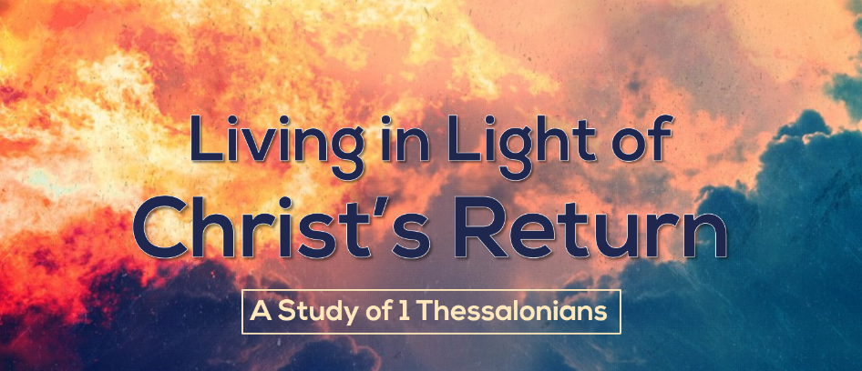
\

We Get to Disciple!
Text: 1 Thessalonians 1:1-5
Discipleship should be a way of life. It should be why we get up in the morning and go to bed at night. It should be what drives our thoughts, desires, actions, plans, and purposes. We should eat, sleep, and breathe discipleship. It’s not another to tack onto our schedules, it should be what our schedules are shaped around. Discipleship should be a way of life. As we study 1 Thessalonians, we are going to see what successful discipleship looks like and how we can be a part of it.
- The Elements of Discipleship
Good planning strategy means beginning with the end in mind. We should be asking the question – what does successful discipleship look like?
- Mature disciples have faith that produces works.
- Works of purity
- Works of service
- Mature disciples have love that produces labor.
- Mature disciples have hope that produces endurance.

- The Elements of Discipleship
As we watch Paul’s life and his interaction with the Thessalonian church, we learn a lot about the kinds of things that produce mature disciples.

- Discipleship is a team effort.
This letter is written, not just by Paul, but by Paul, Silvanus (Silas), and Timothy. Paul worked on a team, and the whole team cared about the church and its spiritual success.

- Discipleship is a prayer effort.
- Your prayer must involve thanksgiving.
- Thanksgiving should be continual.
- Thanksgiving should be comprehensive.
- Your prayer must involve petition.

- Discipleship is God’s effort.
- God the Father elects
- God the Son redeems
- God the Spirit convinces

- Discipleship is a relational effort.

