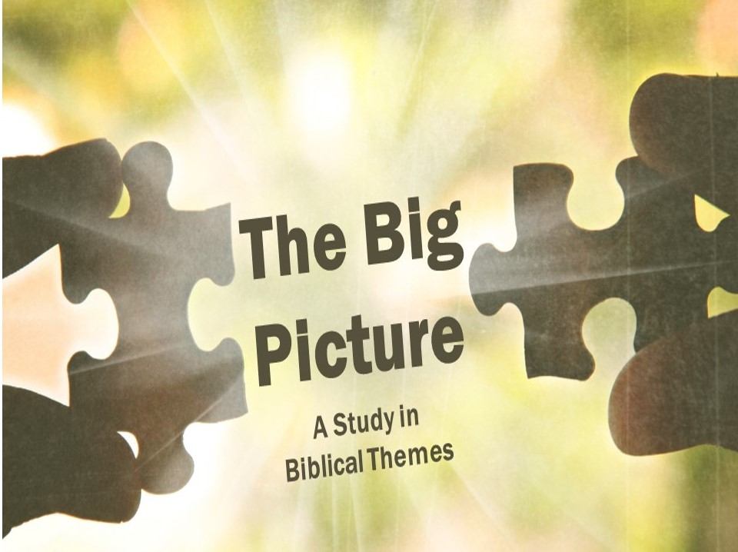

The Temple (Part 2)
Our last lesson ended on a depressing note – God’s presence departed from the temple. God’s people would have to wait 400 more years for that.
- _________________
- A special _________________ (Matthew 1:23)
An angel told Joseph to “’call his name Immanuel’ (which means, God with us).” The glory of the creator God returned to Israel in the form of a little baby.

- A special _________________ (Matthew 17:1-2)
During the transfiguration, the glory of God in Jesus shone through so that everyone there was able to see Jesus for who he really was.

- A special _________________ (John 16:5-7)
Christ tells his disciples that he will leave them, but that is good because when he leaves he will send the Spirit!

- _________________
- _________________from heaven.
The fire representing God’s presence now split and rested over each individual in the upper room.

- _________________believers are the Temple now (1 Corinthians 6:18-20).
Paul reminds a church that has become flippant about immorality that their bodies are the Temple of God.

- Believers as a _________________are the Temple now (Ephesians 2:19-22).
God is here building himself a new temple, and we are the bricks! God dwells in each believer individually, but he also dwells in all believers as a whole.

- _________________
The Temple Ezekiel saw was never built, and (spoiler!) since there is no Temple in the New Jerusalem, it is likely that the temple in Ezekiel will be built in the Millennium.

- New _________________
There is an interesting twist at the end of the story: there is no Temple! God lives directly with his people! So what can we learn from this series?

- Our greatest _________________should be restored fellowship with God.

- We should be _________________for what we have; many before us would love to have what we now have.

- We should eagerly look _________________to the day we live with God face to face.

The Temple (Part 2)
Our last lesson ended on a depressing note – God’s presence departed from the temple. God’s people would have to wait 400 more years for that.
- _________________
- A special _________________ (Matthew 1:23)
An angel told Joseph to “’call his name Immanuel’ (which means, God with us).” The glory of the creator God returned to Israel in the form of a little baby.

- A special _________________ (Matthew 17:1-2)
During the transfiguration, the glory of God in Jesus shone through so that everyone there was able to see Jesus for who he really was.

- A special _________________ (John 16:5-7)
Christ tells his disciples that he will leave them, but that is good because when he leaves he will send the Spirit!

- _________________
- _________________from heaven.
The fire representing God’s presence now split and rested over each individual in the upper room.

- _________________believers are the Temple now (1 Corinthians 6:18-20).
Paul reminds a church that has become flippant about immorality that their bodies are the Temple of God.

- Believers as a _________________are the Temple now (Ephesians 2:19-22).
God is here building himself a new temple, and we are the bricks! God dwells in each believer individually, but he also dwells in all believers as a whole.

- _________________
The Temple Ezekiel saw was never built, and (spoiler!) since there is no Temple in the New Jerusalem, it is likely that the temple in Ezekiel will be built in the Millennium.

- New _________________
There is an interesting twist at the end of the story: there is no Temple! God lives directly with his people! So what can we learn from this series?

- Our greatest _________________should be restored fellowship with God.

- We should be _________________for what we have; many before us would love to have what we now have.

- We should eagerly look _________________to the day we live with God face to face.

