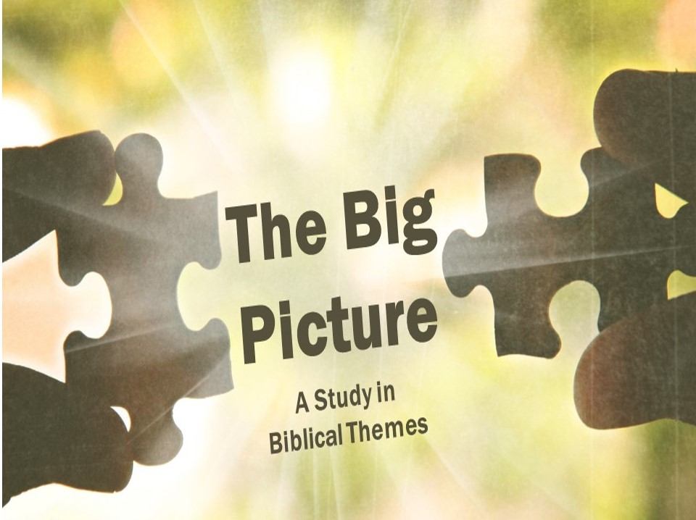

The Temple (Part 1)
The Temple was viewed as God’s house, where God and man met. God lived in the Temple in the sense that he was there among his people.
- ______________ – God and man living together.
- God and man ______________ together.
Genesis 3:8 teaches us that in some way or another, God and man had close fellowship, regularly fellowshipping in the cool of the day!

- ________________ (and ______________) lost.
But man sinned against God and would have no more evening talks. The great tragedy of being expelled was that mankind was kept from living in the God’s presence. This is the great problem of the Bible – how can man be restored to a place of fellowship and service under God now that he has rebelled against God?

- _______________ and ______________ – God’s glory returns to dwell among men.
- _____________ is back.
Many biblical scholars have observed that the Temple was designed to be a sort of “new Eden.” This is because the description of the carvings of the Temple make it sound like a garden (1 Kings 6:18, 29-36, 7:18-20) and the presence of God is guarded by Cherubim, just like Eden.

- ________________ is back.
At the conclusion of the dedication of both Temple and Tabernacle, God shows up in a big way (Exodus 40:34-38; 2 Chron 7:1-3). God’s glory came and filled the Tabernacle and Temple so fully that no one could enter at first. God had returned to humanity and was again dwelling among his people!

- _______________ – God’s glory departs from Israel.
- You broke the ____________
God had made a statement early on when he killed Aaron’s sons for switching up the incense formula (Leviticus 10:1-3), but when we get to Ezekiel the level of wickedness had reached unimaginable lengths (Ezekiel 8:5-18), so God leaves, a little at a time (Ezekiel 10:4, 18-19; 11:22-23).

- Not the _______________
At the end of the Old Testament we read about the Temple being rebuilt by Zerubbabel – kind of. God wanted it built and even sent Haggai to stir the people up when they quit. But when the new Temple was consecrated, there was no filling by God’s presence. We don’t read about the glory of the presence of God coming on this Temple (Haggai 2:6-9). God had promised a glorious return and an incredible new Temple (Ezekiel 40-48), but the exiles who returned were pretty disappointed (Ezra 3:12-13).

The Temple (Part 1)
The Temple was viewed as God’s house, where God and man met. God lived in the Temple in the sense that he was there among his people.
- ______________ – God and man living together.
- God and man ______________ together.
Genesis 3:8 teaches us that in some way or another, God and man had close fellowship, regularly fellowshipping in the cool of the day!

- ________________ (and ______________) lost.
But man sinned against God and would have no more evening talks. The great tragedy of being expelled was that mankind was kept from living in the God’s presence. This is the great problem of the Bible – how can man be restored to a place of fellowship and service under God now that he has rebelled against God?

- _______________ and ______________ – God’s glory returns to dwell among men.
- _____________ is back.
Many biblical scholars have observed that the Temple was designed to be a sort of “new Eden.” This is because the description of the carvings of the Temple make it sound like a garden (1 Kings 6:18, 29-36, 7:18-20) and the presence of God is guarded by Cherubim, just like Eden.

- ________________ is back.
At the conclusion of the dedication of both Temple and Tabernacle, God shows up in a big way (Exodus 40:34-38; 2 Chron 7:1-3). God’s glory came and filled the Tabernacle and Temple so fully that no one could enter at first. God had returned to humanity and was again dwelling among his people!

- _______________ – God’s glory departs from Israel.
- You broke the ____________
God had made a statement early on when he killed Aaron’s sons for switching up the incense formula (Leviticus 10:1-3), but when we get to Ezekiel the level of wickedness had reached unimaginable lengths (Ezekiel 8:5-18), so God leaves, a little at a time (Ezekiel 10:4, 18-19; 11:22-23).

- Not the _______________
At the end of the Old Testament we read about the Temple being rebuilt by Zerubbabel – kind of. God wanted it built and even sent Haggai to stir the people up when they quit. But when the new Temple was consecrated, there was no filling by God’s presence. We don’t read about the glory of the presence of God coming on this Temple (Haggai 2:6-9). God had promised a glorious return and an incredible new Temple (Ezekiel 40-48), but the exiles who returned were pretty disappointed (Ezra 3:12-13).

