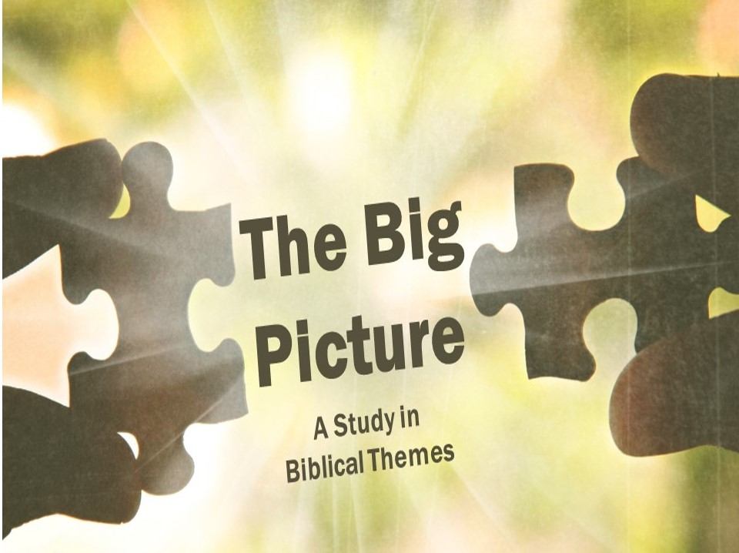

The Mosaic Covenant
God makes lots of deals (covenants) with individuals, but in the book of Exodus he makes a deal with the entire nation of Israel. After rescuing them, God enters a relationship with his people at Mount Sinai, letting them know what he expects of them now that they are his people.
God and Israel enter a covenant at Sinai (Ex 19-24)
- The _______________ for the covenant (Exodus 19)
God’s meeting with Israel was a fierce and awe-inspiring event that Israel was instructed to take very seriously. Later, the New Testament will meditate on what this ought to mean for believer (Hebrews 12:18-29).

- The _______________ of the covenant (Exodus 20-23)
After giving the 10 commandments, God instructs his people on how they should live their lives: religiously pure and socially kind and fair.

- The _______________ of the covenant (Exodus 24)
Israel agrees to do everything that God has asked of them, and the covenant is ratified with a blood sacrifice and a covenant meal.

God reiterates the covenant
After the initial generation dies off in the wilderness, Moses reiterates the covenant to the next generation before they enter the Promised Land.
- God calls his people to ____________ (Deuteronomy 6:4-5)
- God calls his people to ____________ (Deut 12-26).
- God gives warnings and ____________ (Deut 27-28)

Israel breaks the covenant
- The ____________ ____________
After agreeing to follow the covenant, Israel starts worshipping an idol less than a month and a half later!

- The ____________
During the period of the judges, the people went back and forth between worshipping God and living for idols.

- The ____________
Once Israel has a king, things improve temporarily, but it’s only a matter of time until idol worship and other violations of the covenant become the norm again.
God promises a new covenant
Since Israel broke the covenant over and over, God promised that he would create a new covenant with Israel. This covenant would be internal, rather than external. This covenant would result in everyone knowing God. This is the covenant Jesus started, and to this covenant we will turn next week.

The Mosaic Covenant
God makes lots of deals (covenants) with individuals, but in the book of Exodus he makes a deal with the entire nation of Israel. After rescuing them, God enters a relationship with his people at Mount Sinai, letting them know what he expects of them now that they are his people.
God and Israel enter a covenant at Sinai (Ex 19-24)
- The _______________ for the covenant (Exodus 19)
God’s meeting with Israel was a fierce and awe-inspiring event that Israel was instructed to take very seriously. Later, the New Testament will meditate on what this ought to mean for believer (Hebrews 12:18-29).

- The _______________ of the covenant (Exodus 20-23)
After giving the 10 commandments, God instructs his people on how they should live their lives: religiously pure and socially kind and fair.

- The _______________ of the covenant (Exodus 24)
Israel agrees to do everything that God has asked of them, and the covenant is ratified with a blood sacrifice and a covenant meal.

God reiterates the covenant
After the initial generation dies off in the wilderness, Moses reiterates the covenant to the next generation before they enter the Promised Land.
- God calls his people to ____________ (Deuteronomy 6:4-5)
- God calls his people to ____________ (Deut 12-26).
- God gives warnings and ____________ (Deut 27-28)

Israel breaks the covenant
- The ____________ ____________
After agreeing to follow the covenant, Israel starts worshipping an idol less than a month and a half later!

- The ____________
During the period of the judges, the people went back and forth between worshipping God and living for idols.

- The ____________
Once Israel has a king, things improve temporarily, but it’s only a matter of time until idol worship and other violations of the covenant become the norm again.
God promises a new covenant
Since Israel broke the covenant over and over, God promised that he would create a new covenant with Israel. This covenant would be internal, rather than external. This covenant would result in everyone knowing God. This is the covenant Jesus started, and to this covenant we will turn next week.

