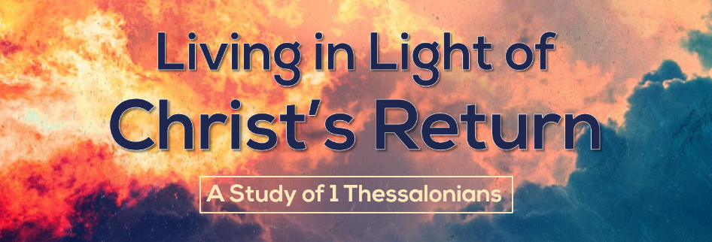

How Do I Know I’ve Accepted God’s Word?
1 Thessalonians 2:13-16
Have you ever watched someone who once claimed to be a Christian but now lives an entirely different life? How do you know when the faith of those around you is real? How do you know when your own faith is real? How do you know you’ve truly accepted and believed God’s Word? That’s the question Paul seeks to answer as he reminisces on his relationship with the Thessalonians. He demonstrates that. . .
Those who accept God’s Word will suffer for God’s Word
- You must accept God’s Word (v 13).
This passage begins by reflecting on the Thessalonians faithfulness in accepting God’s Word.
- Accepting God’s Word causes rejoicing.
Those around us are impacted by the decisions we make, and the spiritual success of our neighbors ought to be a major concern.

- Accepting God’s Word recognizes its source.
There is a wide chasm separating belief in the Bible as a book full of wise insights from spiritual men, and belief in it as the Word of God. Is the Bible your ultimate authority, or is man’s reasoning the ultimate authority?
- Accepting God’s Word changes you.
God’s Word work powerfully in people to change them so that they look more like Jesus Christ! It changed the Thessalonians and it can and will change you!

- You will suffer for God’s Word (v 14-16).
The Thessalonian’s neighbors didn’t accept the conversion of their Christian friends and relatives for a few reasons. . .
- Idolatry was supposed to appease the gods so bad things wouldn’t happen to the community.
- Idolatry was a cultural thing that was important in the life of all Thessalonians (like Christmas or Easter).
- Idolatry was tied to politics, and loyal citizens worshipped the idols and the emperor

- Suffering for God’s Word is normal (v 14).
Suffering for the truth may seem odd, but it is part of God’s plan for the believer.

- Suffering for God’s Word is part of war (vv 15-16).
What the Thessalonians faced was similar to what the Judean Jews had faced. Although it was the Jews and not the Romans persecuting them, all persecutors share certain characteristics. . .
- Unbelievers reject God’s message.
- Unbelievers persecute God’s spokesmen.
- Unbelievers incur God’s wrath.
- Unbelievers oppose everyone.
God gives us the strength we need when difficult times come to take our stand, to suffer for his Word, and to remain true to him (1 Thessalonians 5:23-24). With his help, we can and must remain true to his Word!

