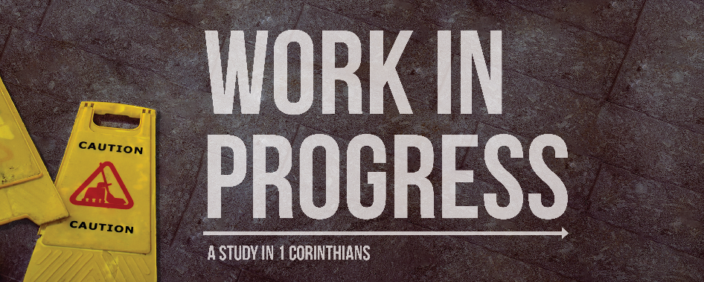
Principles to Live By
1 Corinthians 10:23-11:1
We all live by principles, whether consciously or without really giving it much thought. In this section, Paul sums up what he has been talking about by going over principles the Corinthians should use when living for God in a world overflowing with idols and idolatry. Here Paul reviews 3 principles he has already gone over and finishes with a strong final principle through which we should run all our decisions.

The Insufficient Principle – Is It Forbidden?
“All things are lawful for me”
The Corinthians were basically operating on one principle – is it forbidden? If it’s lawful (and in their mind, basically everything was), then it’s okay! Paul contradicts this wrong assertion with our first two principles that we will see below.
Why do we tend to want to limit our consideration of God’s Word to “what does it forbid?” ________________________
___________________________________________________
___________________________________________________
Can you think of any other places in Scripture where this mentality is warned against?___________________________
___________________________________________________
___________________________________________________

Spiritual Benefit: Does it help me?
“All things are not expedient [helpful]”
The first question we should ask is whether something helps us or hurts us spiritually. God created a good world, but that world has been tainted by sin and we need careful discernment to know what will make us more like Christ and what will make it harder to love and be like Christ.
How can you determine if something is spiritually helpful or spiritually harmful?___________________________________
___________________________________________________
___________________________________________________
Have you ever given something up that the Bible never said you couldn’t have, but you simply found it weighing you down?
___________________________________________________
___________________________________________________

Spiritual Building: Does it edify brothers?
“All things edify not”
Paul takes an earlier principle – don’t do things that might harm another believer – and takes it up a notch – only do things that help other believers. One of the main questions we should ask before participating in any activity is, “Will this help others love and live for God?”
How can our choices help others be more like Christ? ______
___________________________________________________
___________________________________________________
Why do we tend to be ambivalent about the spiritual growth of others around us, especially if we aren’t close friends with them? _____________________________________________
___________________________________________________
___________________________________________________

Spiritual Boldness: Does it advance the gospel?
“Conscience, I say, not thine own, but of the other”
Finally, Paul points out to Corinth that God cared very much about their participation in idolatry, because God is a jealous God. God wants all the affection of his people, and he is not willing to share our attention or our hearts with anyone, certainly not with idols.
What happened in the Old Testament when God got jealous over Israel and Judah? _______________________________
___________________________________________________
___________________________________________________

In what ways can modern day believers provoke God to jealousy by the way that they live? ______________________
___________________________________________________
___________________________________________________

Spiritual Big Picture: Does it bring God glory?
“Whether … ye eat, or drink … do all to the glory of God”
As Paul concludes this issue what is and isn’t okay to eat, he gives an overarching principle that sums up the other three – live for God’s glory. And as you do that, follow the example of people like Paul as they follow the example of Christ.
Which of the first three principles (spiritual benefit, spiritual building, spiritual boldness) do you find the hardest to use when making decisions? Why do you think that is? ______
___________________________________________________
___________________________________________________
___________________________________________________
Who are some examples that you have looked up to for guidance on how to live a life that brings God glory? ________
___________________________________________________
___________________________________________________
___________________________________________________

