Lesson 2
The Circle(s) of Life
Ecclesiastes 1:1-11

Life seems to go in circles. Every day you wake up, get ready, go to work or school, eat your meals, do your job, go home, have a little fun, attend to a few things, get ready for bed, put your head on the pillow, and go to sleep. The following morning, you wake up and do the same thing all over again. Your days repeat themselves. Weeks, months, and years repeat themselves. History repeats itself. The earth goes through its own cycles of repetition.

And sometimes, when we step back and reflect on the cycles of life, it prompts us to ask ourselves, “Is there any meaning in all of this activity? Is there any meaning in this rat race of life?” That is the question that the Preacher wrestles through in chapter 1 of Ecclesiastes. Can we discover value in the cycles of life? He walks us through some wise facts of life that help us wrestle through this question.

Wise Fact #1: Life is Vapid (vs. 1-2)
- Life is vapid (hevel).
- Life is vapid (hevel).

Can meaning be found in the passing cycles of life?

Wise Fact #2: Mankind is Vapid (vs. 3-4).
- Generations .
- Generations go.

Value in the circle of life is found in God alone, the of mankind.

Other Notes:

Wise Fact #3: Creation is cyclical (vs. 5-7).
- The sun through its cycles (v. 5).
- The wind blows thorough its cycles (v. 6).
- The waters through their cycles (v. 7).

Value in the circle of life is found in God alone, the of all Creation.

Other Notes:

Wise Fact #4: Life is often unsatisfying (v. 8).
- Our words can never enough.
- Our eyes can never see enough.
- Our ears can never enough.

Value in the circle of life is found in God alone, the true source of .

Other Notes:

Wise Fact #5: Nothing is actually new (vs. 9-10).
- Things that happened in the past will again (v. 9a).
- Things that are happening now will happen again (v. 9b).
- Things that are happening now happened before (v. 10).

Value in the circle of life is found in God alone, who fully understands everything that has happened, is happening, and will happen.

Other Notes:

Wise Fact #6: Most things are forgotten (v. 11).
- Past is forgotten.
- history will be forgotten.

Value in the circle of life is found in God alone, the of human history.

Other Notes:

Prayer
Scripture: ²⁰ According to my earnest expectation and my hope, that in nothing I shall be ashamed, but that with all boldness, as always, so now also Christ shall be magnified in my body, whether it be by life, or by death. ²¹ For to me to live is Christ, and to die is gain.
Philippians 1:20-21

College Student of the Night: Jared Morrison
- Senior Engineering Student at Cedarville University
- Prayer Requests:
  - Graduation coming in May
  - Wisdom for his next job and place to move to.

Single Focus/Cross Impact Requests:
- Cross Impact IUPUI, Purdue, Ball State, and UIndy
- Potential at IU, Marion, and Butler
- Single Focus (Connect, Grow, Serve)
- Sunday Soul-Winning Efforts

Specific Requests:
- Jack Elms, Kendall Elms, Jesiah Achenbach in military training/service
- Joseph LaPointe’s back and spirit
- Trevor’s need for community at Indiana State
- Jessica’s Unsaved friend in Mormonism
- Sarah’s family’s salvation
- Aaron Bott and family- Soldier in Kuwait (Joe Forti’s friend)
- Ian’s unsaved family
- Hau’s work friend who lost her baby and is recovering
- Elizabeth’s coworker who is recovering from surgery and needs to have strong recovery.

Announcements:
- February 16-17- NBA Allstar Weekend Hangout
- July 19-21- Kenosha Missions Trip Signup
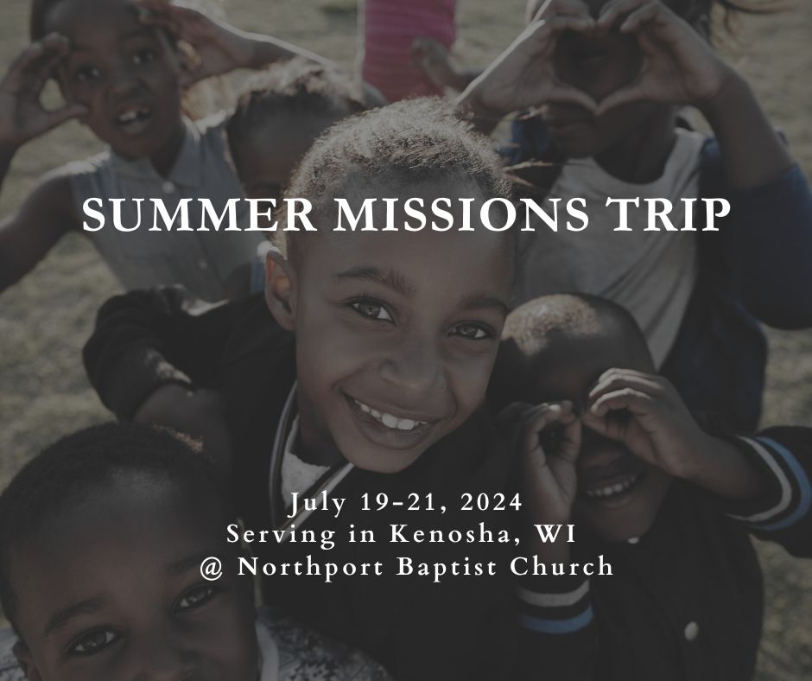

Order of Service for tonight:
- Opening Game: What State?
- Announcements:
- Opener: Andy
- Songs:
  - To Live or Die (on screen)
  - It is Not Death to Die (page 71)
- Prayer:
- Message: Pastor Andy

