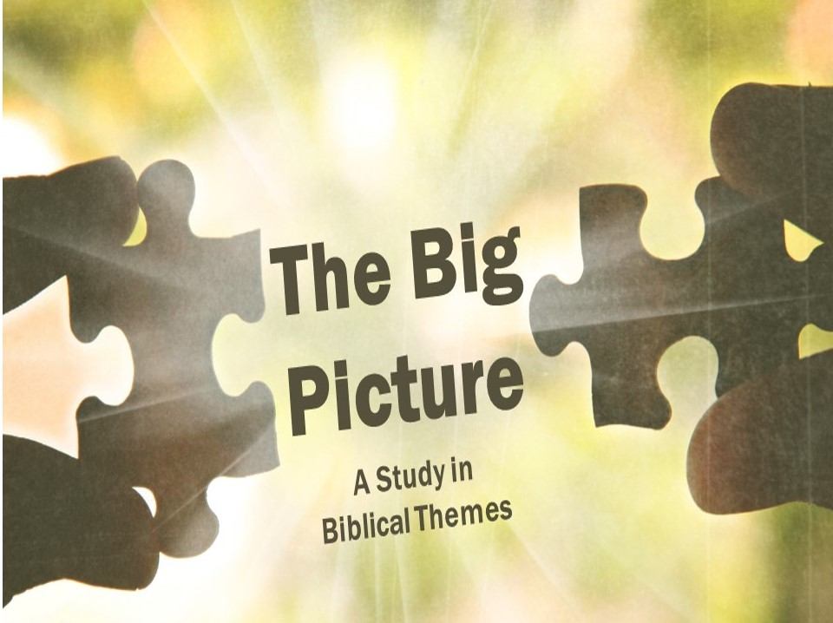

The Abrahamic Covenant
Promises are a big deal. Few things twist someone’s arm quite like the phrase “You promised!” In the Bible, God makes several covenants, or agreements with people, in which he promises to do things for them. Through these covenants God unfolds his plan to undo what the serpent has done in the garden and to ultimately bring about the Seed who will defeat him.
God Promised Abraham a Seed
- God’s _____________ Promise (Genesis 12:2)
God promises Abraham that he will have a seed, a son, and that an entire nation will come from that seed.

- God ____________ His Promise (Genesis 17:15-21; 18:9-15)
Even though both Abraham and his wife are too old to have kids, God reaffirms that he will give Sarah a son, and that God’s blessings are through Isaac. Throughout Genesis, we will see God focus on the special descendant, from Isaac, to Jacob, to Judah. God is narrowing the focus of where the special seed will come from.

God Promised Abraham Land
- God’s _____________ Promise (Genesis 12:1; 15:18-21)
God promised Abraham all the land of Canaan, from Euphrates to the River of Egypt. That’s a lot of land! Even though Abraham never had it all, he trusted God would fulfill his Word to Abraham’s descendants.

- The ____________ Fulfillment of the Promise (1 Kings 4:21)
Israel, under the reign of Solomon, did briefly possess all the land, but this only lasted until the civil war under his son.

- The ____________ Fulfillment (Genesis 17:8)
God had promised Abraham that the land would be an everlasting possession, however. Millennial promises point to a future fulfillment of Israel possessing the land according to the original dimensions God gave, because God hasn’t forgotten his promise (Ezekiel 37:11-14; Romans 11:26).
God Promised Abraham a Blessing
- _____________ Application (Acts 3:25)
Peter points out that even though Christ is a blessing to all nations, he was a blessing to the people of Israel first. The blessing here is described as turning them from their own wickedness.

- _____________ Application (Galatians 3:7-9)
Paul argues that God gave Abraham the gospel! God hinted at what he was up to through Abraham’s seed by telling him that through Abraham all the world would be blessed.

The Abrahamic Covenant
Promises are a big deal. Few things twist someone’s arm quite like the phrase “You promised!” In the Bible, God makes several covenants, or agreements with people, in which he promises to do things for them. Through these covenants God unfolds his plan to undo what the serpent has done in the garden and to ultimately bring about the Seed who will defeat him.
God Promised Abraham a Seed
- God’s _____________ Promise (Genesis 12:2)
God promises Abraham that he will have a seed, a son, and that an entire nation will come from that seed.

- God ____________ His Promise (Genesis 17:15-21; 18:9-15)
Even though both Abraham and his wife are too old to have kids, God reaffirms that he will give Sarah a son, and that God’s blessings are through Isaac. Throughout Genesis, we will see God focus on the special descendant, from Isaac, to Jacob, to Judah. God is narrowing the focus of where the special seed will come from.

God Promised Abraham Land
- God’s _____________ Promise (Genesis 12:1; 15:18-21)
God promised Abraham all the land of Canaan, from Euphrates to the River of Egypt. That’s a lot of land! Even though Abraham never had it all, he trusted God would fulfill his Word to Abraham’s descendants.

- The ____________ Fulfillment of the Promise (1 Kings 4:21)
Israel, under the reign of Solomon, did briefly possess all the land, but this only lasted until the civil war under his son.

- The ____________ Fulfillment (Genesis 17:8)
God had promised Abraham that the land would be an everlasting possession, however. Millennial promises point to a future fulfillment of Israel possessing the land according to the original dimensions God gave, because God hasn’t forgotten his promise (Ezekiel 37:11-14; Romans 11:26).
God Promised Abraham a Blessing
- _____________ Application (Acts 3:25)
Peter points out that even though Christ is a blessing to all nations, he was a blessing to the people of Israel first. The blessing here is described as turning them from their own wickedness.

- _____________ Application (Galatians 3:7-9)
Paul argues that God gave Abraham the gospel! God hinted at what he was up to through Abraham’s seed by telling him that through Abraham all the world would be blessed.

